**Industrial Training Report**

**A Thesis Submitted**

**In Partial Fulfilment of the Requirement**

**For the Degree of**

**MASTER OF COMPUTER APPLICATION**

**Submitted by**

**Nitin Sharma – (1900290149069)**

**Under the Supervision of**

**Prof. Ankit Verma**

**(Assistant Professor)**

**Department of Computer Applications,**

**KIET Group of Institutions,**

**Delhi-NCR, Ghaziabad**

**to the**

**Faculty of Computer Application**

**DR. APJ ABDUL KALAM TECHNICAL UNIVERSITY**

**LUCKNOW**

**(Formerly Uttar Pradesh Technical University, Lucknow)**

**June 2021**

**Declaration**

I hereby declare that the work presented in this report entitled “THESIS TITLE", was carried out by me. I have not submitted the matter embodied in this report for the award of any other degree or diploma of any other University or Institute.

I have given due credit to the original authors/sources for all the words, ideas, diagrams, graphics, computer programs, experiments, results, that are not my original contribution. I have used quotation marks to identify verbatim sentences

and given credit to the original authors/sources.

I affirm that no portion of my work is plagiarized, and the experiments and results reported in the report are not manipulated. In the event of a complaint of plagiarism and the manipulation of the experiments and results, I shall be fully

responsible and answerable.

Name : Nitin Sharma

Roll. No. : 1900290149069

Branch : MCA

Nitin Sharma

**(Candidate Signature)**

**Table of Contents**

1. Introduction
2. Technologies / Software Requirements
3. Hardware requirement / Hardware Used
4. Featuring and Images
5. DFD
6. Gantt Chart (In terms of weeks)
7. Feasibility Study
8. Test Case
9. Conclusion
10. References

**Introduction**

**FlexGrid for WPF** is a lightweight data grid control designed on a flexible object model. Based on the popular WinForms version, **FlexGrid** offers many unique features such as unbound mode, flexible cell merging, and multi-cell row and column headers that make it a proven solution for data management and tabulation.

Like other data visualization controls, FlexGrid supports bound mode and can be populated with data from various data sources. The below section discusses bound FlexGrid in .NET 4.5.2 and .NET 5 versions.

The C1FlexGrid class provides the **ItemsSource** property to populate data in the grid. In WPF, the ItemsSource property binds FlexGrid to **IEnumerable** interface, or to DataCollection interface.

The following image shows a bound FlexGrid.

The following code examples illustrate how to bind a list of customer objects to FlexGrid control. The code below causes the grid to scan the data source and automatically generate columns for each public property of the items in the data source. You can also customize automatically created columns using code, or disable automatic column generation altogether and create custom columns through code or XAML.

FlexGrid can also be bound directly to a list (customer list). However, binding to **DataCollection** is usually better as it retains a lot of the data configuration for the application, which can be shared across controls.

The FlexGrid control is designed to work with various data sources and collections such as ObservableCollection and DataCollection to leverage its full capabilities. However, the control is not restricted to data sources and can be used in unbound mode

To create an unbound grid, add rows and columns to the grid using the Add method. The following code illustrates adding rows and columns in a grid and populating it with an indexing notation that specifies a cell by corresponding row and column index.

FlexGrid offers several advanced data visualization features that are beyond simple grids. These features are listed below:

* **Flexible data binding**  
  FlexGrid can be used in bound mode, where it displays data from a data source, or in unbound mode, where the grid itself manages the data.
* **Advanced grid features**  
  FlexGrid supports advanced grid features including cell merging, data filtering, sorting, editing, aggregation etc. You can merge contiguous, like-valued cells to make the data span across multiple cell; calculate totals averages, and other statistics for ranges of cells; and apply filters to each column on the grid.
* **Hierarchical styles**  
  FlexGrid summarizes data in hierarchical style like a tree. Each record can be expanded or collapsed to expose details in child grids.
* **Integrated printing support**  
  FlexGrid supports integrated printing wherein it has control over paper orientation, margins, and footer text. With a rich object model, the control provides varied printing events to handle page breaks, add repeating header rows, or add custom elements to each page. You can also show a dialog to let users select and set up the printer.
* **Advanced grouping and filtering feature**  
  FlexGrid supports grouping as a UI feature through a separate control, FlexGridGroupPanel, available as a separate assembly. Similarly, the control comes with FlexGridFilter component, which provides ad-hoc filtering and is shipped separately to achieve lower footprint.
* **Custom cells**  
  FlexGrid supports significant customization in the grid through custom cells. The control provides CellFactory class and built-in CellTemplate and CellEditingTemplate to customize visual elements.
* **Row details**  
  FlexGrid provides the flexibility to show row details in a data template, which can be used to display text, images as well as data bound controls.
* **Freezing and Pinning**  
  This feature allows you to freeze the rows and columns using mouse drag during runtime. A column or multiple columns can be pinned to the left-hand side of the FlexGrid. Column Pinning in FlexGrid allows the you to lock column in a particular column order, this will allow you to see it while horizontally scrolling the Grid.

**Technologies / Software Requirements**

* Operating System : Windows
* Programming language: C#, WPF(.Net Framework)
* Front-End: XAML
* Back-End: .Net Framework DataTable through JSON
* IDE: Visual Studio 2019
* API Control: Component One Flexgrid

**Hardware requirement / Hardware Used**

* Windows Version- Windows.
* 2 GB Ram
* 1MB Cache Memory
* External Memory 10 GB

**Featuring and Images**

**FlexGrid for WPF** is a lightweight data grid control designed on a flexible object model. Based on the popular WinForms version, **FlexGrid** offers many unique features such as unbound mode, flexible cell merging, and multi-cell row and column headers that make it a proven solution for data management and tabulation.

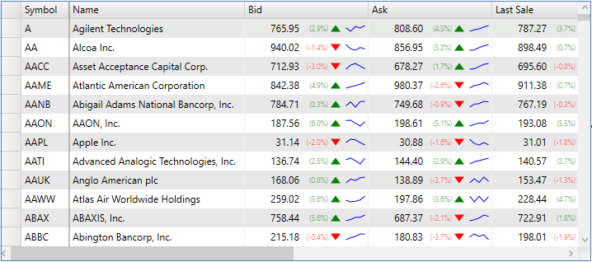

| **API References** |  |
| --- | --- |
| C1.WPF.FlexGrid.4.5.2 Assembly | C1.WPF.Grid Assembly |

**Note:** ComponentOne FlexGrid control is compatible with both **.NET 4.5.2** and **.NET 5 Frameworks.**

Like other data visualization controls, FlexGrid supports bound mode and can be populated with data from various data sources. The below section discusses bound FlexGrid in .NET 4.5.2 and .NET 5 versions.

The C1FlexGrid class provides the **ItemsSource** property to populate data in the grid. In WPF, the ItemsSource property binds FlexGrid to **IEnumerable** interface, or to DataCollection interface.

The following image shows a bound FlexGrid.

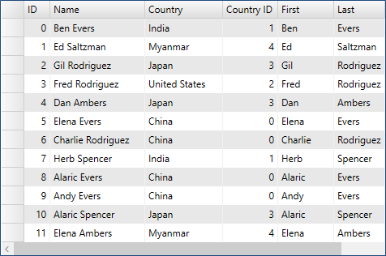

The following code examples illustrate how to bind a list of customer objects to FlexGrid control. The code below causes the grid to scan the data source and automatically generate columns for each public property of the items in the data source. You can also customize automatically created columns using code, or disable automatic column generation altogether and create custom columns through code or XAML.

grid.ItemsSource = Customer.GetCustomerList(12);

FlexGrid can also be bound directly to a list (customer list). However, binding to **DataCollection** is usually better as it retains a lot of the data configuration for the application, which can be shared across controls.

The FlexGrid control is designed to work with various data sources and collections such as ObservableCollection and DataCollection to leverage its full capabilities. However, the control is not restricted to data sources and can be used in unbound mode.

The image given below shows an unbound grid populated with cell index notation.

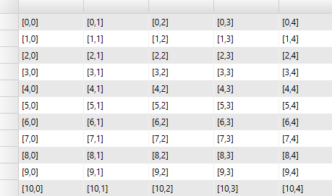

To create an unbound grid, add rows and columns to the grid using the Add method. The following code illustrates adding rows and columns in a grid and populating it with an indexing notation that specifies a cell by corresponding row and column index.

The indexing notation displayed in the grid specifies a cell by row and column index. The cells can also be specified by row index and column name, or by row index and column name. The indexing notation works in bound and unbound modes. In bound mode, the data is retrieved or applied to the items in the data source. In unbound mode, the data is stored internally by the grid.

The new indexing notation displayed in the grid contains no items in the 0th row. This notation makes indexing easier as the indices match the index of data items and the column count matches the number of displayed properties. The only drawback of this notation is that a new method is required to access the content of fixed cells

Most grid controls allow users to select parts of the data using the mouse and the keyboard. FlexGrid supports following selection modes through the **SelectionMode** property of C1FlexGrid class in .NET 4.5.2 version and GridBase class in .NET 5 version:

* **Cell**: To select a single cell.
* **CellRange**: To select a cell range (block of adjacent cells).
* **Row**: To select an entire row.
* **RowRange**: To select a set of contiguous rows.
* **ListBox**: To select an arbitrary set of rows (not necessarily contiguous).

The default **SelectionMode**is **CellRange**, which provides an Excel-like selection behavior. The row-based options are also useful in scenarios where it makes sense to select whole data items instead of individual cells. Regardless of the selection mode, FlexGrid exposes the current selection with the Selection property. This property gets or sets the current selection as a **CellRange**object.

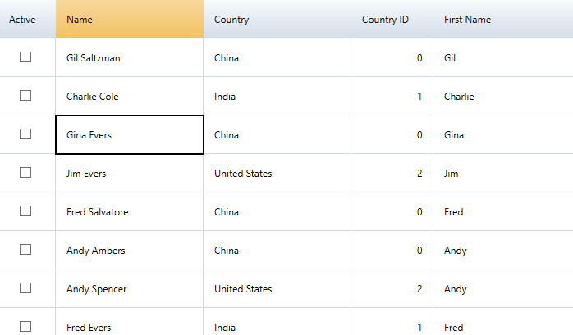

FlexGrid includes two features that allow you to customize the way in which the selection is highlighted for the user.

### Excel-Style Marquee

If you set the ShowMarquee property to true, the grid automatically draws a rectangle around the selection, making it extremely easy to see. By default, the marquee is a two-pixel thick black rectangle, but you can customize it using the Marquee property.

### Selected Cell Headers

If you assign custom brush objects to the grid’s ColumnHeaderSelectedBackground and RowHeaderSelectedBackground properties, the grid highlights headers that correspond to the selected cells, making it easy for users to see which rows and columns contain the selection.

Together, these properties let you implement grids that have the familiar Excel look and feel. The image below shows an example:

FlexGrid designer provides a context menu with options to select Excel-like color schemes (Blue, Silver, Black). In addition, you can easily copy the XAML generated by the designer into reusable style resources.

**FlexGrid** control by default lets you to **sort** by any column. The user simply has to click on the header of a column to toggle between the sorting states, ascending and descending.

If a user clicks the column header, it sorts by that column. In this case, the column header shows an upward pointing arrow indicating ascending order. Likewise, if a user clicks the column header once more, that is, the second time, the column sorts in descending order, with the arrow pointing downwards.

The snapshot below depicts sorting feature by the "Description" and "UnitPrice" columns:

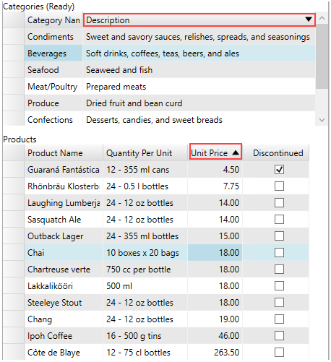

The user can also choose to set the AllowSorting property in C1FlexGrid class or AllowSorting property in the Column class to 'false' to prevent sorting in the entire FlexGrid control or a desired column within the control.

FlexGrid supports cell merging to allow data to span across multiple rows and columns. The cell merging capability can be used to enhance the appearance of data.

In the following section learn how to implement cell merging in FlexGrid .NET 4.5.2 and .NET 5 versions.

Cell merging can be enabled by setting the **AllowMerging** property of C1FlexGrid in code. To merge columns, you need to set the AllowMerging property for each column that you want to merge to **true**.

Similarly, to merge rows, set the AllowMerging property to **true** for each row to be merged. You can use **AllowMerging** **Enum** to specify areas like **Cells**, **ColumnHeaders** etc. of the grid for merging.

The following image shows merged columns in a FlexGrid.

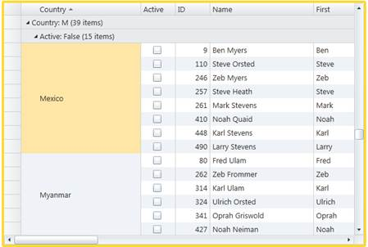

The code below illustrates merging columns (cells) containing the same **country and name**.

FlexGrid displays various icons during its operations such as sorting, filtering etc. These icons can be changed using various icon templates provided in the FlexGrid control. These icon templates can be accessed through following properties.

You can change the icons set by these templates either to the built-in icons provided by the FlexGrid or to your own custom image, geometric figures, font etc as an icon.

The following image displays a custom image which is set as a sort icon for sorting values in descending order.

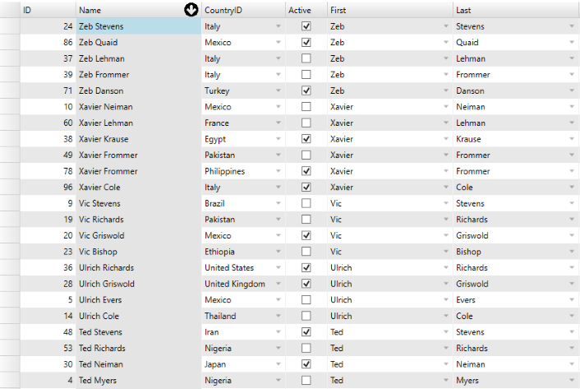

FlexGrid also allows you to change the appearance of the different icons used in the control using the C1Icon class. The C1Icon class is an abstract class that provides a series of different objects that can be used for displaying monochromatic icons which can easily be tinted and resized.

FlexGrid supports grouping through I**DataCollection** interface. You can create hierarchical views in FlexGrid by defining each level of grouping through the **PropertyGroupDescription** class. Using the PropertyGroupDescription object, you can select the property to group data, and implement **ValueConverter** to determine how to use property value while grouping. You can also disable grouping at the grid level by setting the grid's GroupRowPosition property to **None**.

The following image shows data grouped by country and their active state. Users can click the icons on group headers to collapse or expand the groups, as they would do with a TreeView control.

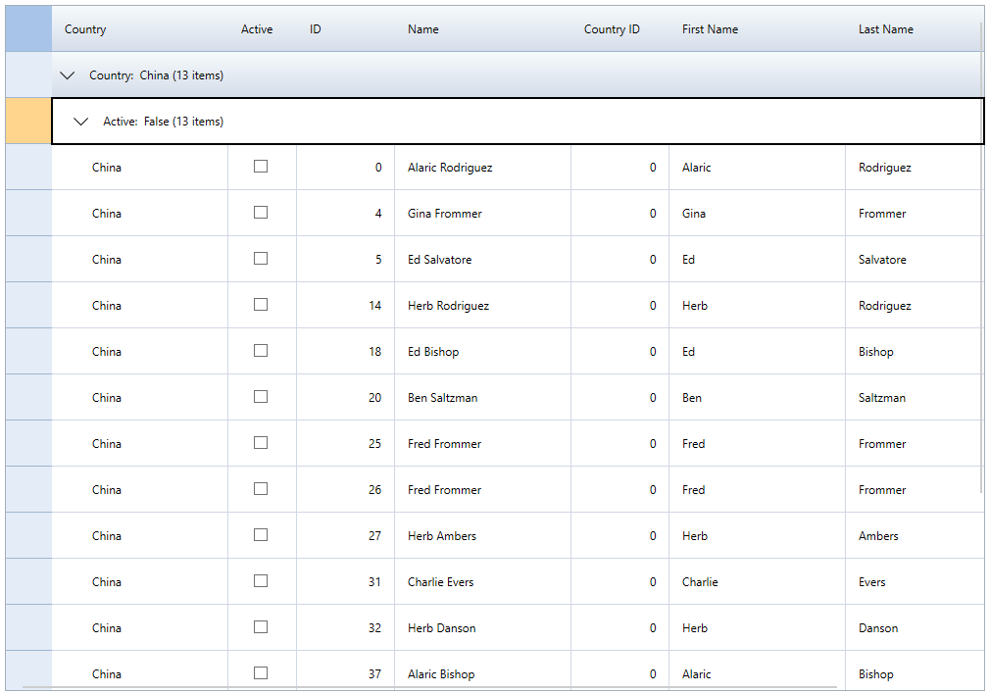

The following code example illustrates data grouping by country and active state through DataCollection.

FlexGrid provides Excel-like filtering feature to filter data through drop down icons in column headers. This functionality is available in FlexGrid through a separate control called FlexGridFilter, which is implemented through an extender assembly, **C1.WPF.FlexGridFilter**. Once the FlexGridFilter control is added, the grid displays a drop-down icon on hovering the column headers. The drop-down icon shows an editor that allows users to specify filters on columns. Users may choose between the two types of filters:

* **Value filter**: This filter lets you filter specific values in the column.
* **Condition filter**: This filter lets you specify conditions composed of an operator (greater than, less than, etc.) and a parameter. The conditions can be combined using an **AND** or an **OR** operator.

**Note:**Filtering using **FlexGridFilter** is only availabe in .NET 4.5.2 version.

The images below show the filters displayed on clicking the drop-down icon.

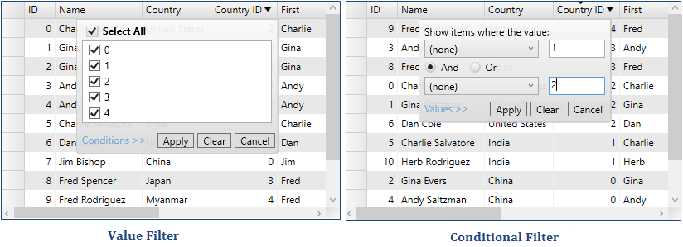

FlexGrid lets you compute and display aggregate value for each group created after grouping data. The control shows groups in a collapsible outline format and automatically displays the number of items in each group. However, you can go one step further and display aggregate values for every grouped column. This feature enables users in drawing out more insights from random data.

In the following section learn how to implement Data Aggregation in FlexGrid .NET 4.5.2 and .NET 5 versions.

In the below example, a company's sales data grouped by country or product category can be more useful if the aggregate sales can be indicated against each country and product category in the grid itself. The Column class provides the **GroupAggregate** property that can be set to **Aggregate** to automatically calculate and display aggregates. The aggregates calculated by setting the GroupAggregate property automatically recalculate the aggregate values when the data changes.

The following image shows a FlexGrid with aggregate values displayed in the columns.

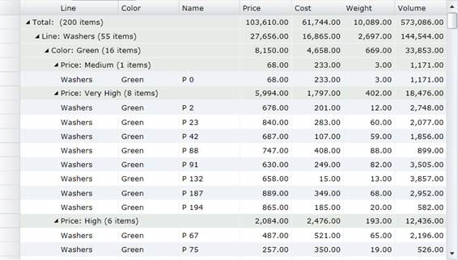

FlexGrid comes with the CellFactory class to create every cell that appears on the grid. You can create custom cells by creating a class in your project that implements the ICellFactory interface and assign it to the CellFactory property of FlexGrid.

Custom ICellFactory classes can be highly specialized and application-specific, or can be very generic and reusable. In general, custom ICellFactory classes are simpler than custom columns since they deal directly with cells. Implementing custom **CellFactory** classes is fairly easy because you can inherit from the default CellFactory class included with the C1FlexGrid class. The default CellFactory class was designed to be extensible, so you can let it handle all the details of cell creation and customize only what you need.

The following image shows custom cells created through CellFactory in FlexGrid.



When using custom cells, it is important to understand that grid cells are transient. Cells are constantly created and destroyed as the user scrolls, sorts, or selects ranges on the grid. This process is known as virtualization and is quite common in WPF applications. Without virtualization, a grid would typically have to create several thousand visual elements at the same time, which would impact its performance.

If you want more control over the printing process, use the GetPageImages method to automatically break up the grid into images that can be rendered onto individual pages. Each image is a 100% accurate representation of a portion of the grid, including styles, custom elements, repeating row and column headers on every page, and so on.

The **GetPageImages** method also allows callers to scale the images so the entire grid renders in actual size, scales to fit onto a single page, or scales to the width of a single page.

Once you have obtained the page images, you can use the WPF printing support to render them into documents with complete flexibility. For example, you can create documents that contain several grids, charts, and other types of content. You can also customize headers and footers, add letterheads, and so on.

The following sections demonstrate how an application can render the **FlexGrid** using the **GetPageImages** onto a print document in either platform.

## **Printing a C1FlexGrid in WPF**

Printing documents in WPF requires the following steps:

1. Create a **PrintDialog** object.
2. If the dialog box’s **ShowDialog** method returns true, then:
3. Create a **Paginator** object that will provide the document content.
4. Call the dialog’s **Print** method.

The code below shows a sample implementation of this mechanism.

Row details template is a data panel that can be added to each row for displaying details. FlexGrid provides the flexibility to show information about each row through a template. You can embed text, UI elements, and data-bound controls, such as InputPanel, in the row details template. For each row, you can insert a data template to present its summary and show/provide details in other controls, such as text box, without affecting the dimensions of the grid. You can also use this template to create hierarchical grids displaying grouped data. In this example, we use row details template to display product-related information in FlexGrid.

The following image shows details of each row displayed through a row details template.

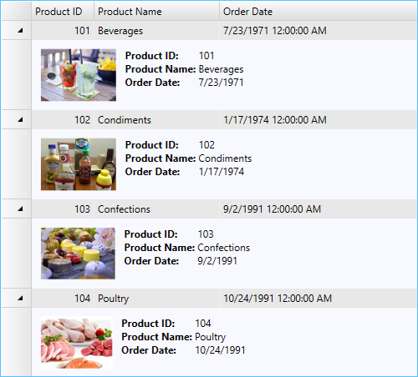

**FlexGrid for WPF** support ComponentOne's new ClearStyle technology that allows you to easily change control colors without having to change control templates. By just setting a few color properties you can quickly style the control.

Each key piece of the control's style is surfaced as a simple color property. This leads to a unique set of style properties for each control. For example, a **Gauge** has **PointerFill** and **PointerStroke** properties, whereas a **DataGrid** has **SelectedBrush** and **MouseOverBrush** for rows.

Let's say you have a control on your form that does not support ClearStyle. You can take the XAML resource created by ClearStyle and use it to help mold other controls on your form to match (such as grabbing exact colors). Or let's say you'd like to override part of a style set with ClearStyle (such as your own custom scrollbar). This is also possible because ClearStyle can be extended and you can override the style where desired.

ClearStyle is intended to be a solution to quick and easy style modification but you're still free to do it the old fashioned way with ComponentOne's controls to get the exact style needed. ClearStyle does not interfere with those less common situations where a full custom design is required.

You can completely change the appearance of the C1FlexGrid control by setting one or more properties, For example, if you set the **AlternatingRowBackground** property to "#FFC3F2F2", the C1FlexGrid control appears similar to the following:

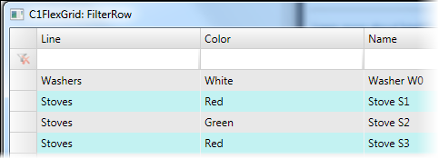

Hover styles are applied to cells when the mouse hovers over the grid. It provides visual cues so that the user can apply styling to a cell, row, column or to a specific cell according to the GridSelectionMode enumeration when they are hovered on prior to selection or editing.

The hover styles can make the FlexGrid appear more "alive" and interactive.



There are two essential properties to consider while performing hover styles, the **MouseOverMode** property and **MouseOverBrush** property in **GridBase** class. The MouseOverMode property helps to set how the mouse hovers over the grid, while the MouseOverBrush property sets a brush to paint the background of the selected cells. Also, **SelectionMode** property is equally important as it helps to set how the cells or rows are selected in the grid, since styling after all is applied based on cell hovering before selection.

Moreover, the SelectionMode property calls the **GridSelectionMode** enumeration, the MouseOverMode property calls the **GridMouseOverMode** enumeration and the MouseOverBrush property calls the **Brush** class.

This feature in **WPF** **FlexGrid** allows you to freeze the rows and columns using mouse drag during runtime following a particular sequence. You can set the [AllowFreezing](https://www.grapecity.com/componentone/docs/wpf/online-flexgrid/C1.WPF.FlexGrid.4.5.2~C1.WPF.FlexGrid.AllowFreezing.html) Enum to **Columns** to freeze only columns, **Rows** to freeze only rows, or **Both** to freeze both columns and rows. Conversely, to disable freezing, set the AllowFreezing Enum to None, which is the default setting. This Enum can be set either in the designer or in code.

### Implementation

**In Designer**

Locate the [AllowFreezing](https://www.grapecity.com/componentone/docs/wpf/online-flexgrid/C1.WPF.FlexGrid.4.5.2~C1.WPF.FlexGrid.AllowFreezing.html) Enum in the Properties window and set it to Rows, Columns, Both or None.

Now, you can manually use the mouse drag to adjust the number of frozen columns and rows as needed.

### Feature Illustration

When the mouse pointer becomes the lock rows or the lock columns icon, click and drag the mouse over the rows or columns to freeze in a sequence. Setting the AllowFreezing Enum to **Both** allows both rows and columns to be frozen at the same time, as seen in the following GIF.



**Coding**

* + **XAML Part**

﻿<UserControl x:Class="StoreSalesRegisterApplication.Pages.DashboardPage"

xmlns="http://schemas.microsoft.com/winfx/2006/xaml/presentation"

xmlns:x="http://schemas.microsoft.com/winfx/2006/xaml"

xmlns:mc="http://schemas.openxmlformats.org/markup-compatibility/2006"

xmlns:d="http://schemas.microsoft.com/expression/blend/2008"

xmlns:local="clr-namespace:StoreSalesRegisterApplication.Pages"

xmlns:myuc="clr-namespace:StoreSalesRegisterApplication.UserControls"

mc:Ignorable="d"

d:DesignHeight="450" d:DesignWidth="800">

<Grid>

<Grid.RowDefinitions>

<RowDefinition Height="Auto"/>

<RowDefinition Height="*"/>

</Grid.RowDefinitions>

<myuc:NavigationBar x:Name="navigationBar"></myuc:NavigationBar>

<Label Content="Dashboard" HorizontalAlignment="Center" VerticalAlignment="Center" Grid.Row="1" FontSize="24"/>

</Grid>

</UserControl>

<UserControl x:Class="StoreSalesRegisterApplication.Pages.OrderPage"

xmlns="http://schemas.microsoft.com/winfx/2006/xaml/presentation"

xmlns:x="http://schemas.microsoft.com/winfx/2006/xaml"

xmlns:mc="http://schemas.openxmlformats.org/markup-compatibility/2006"

xmlns:d="http://schemas.microsoft.com/expression/blend/2008"

xmlns:local="clr-namespace:StoreSalesRegisterApplication.Pages"

xmlns:c1="http://schemas.componentone.com/winfx/2006/xaml"

xmlns:myvm ="clr-namespace:StoreSalesRegisterApplication.ViewModel"

xmlns:myuc="clr-namespace:StoreSalesRegisterApplication.UserControls"

mc:Ignorable="d"

d:DesignHeight="450" d:DesignWidth="800">

<UserControl.Resources>

<myvm:DataViewModel x:Key="dataViewModel"></myvm:DataViewModel>

</UserControl.Resources>

<Grid>

<Grid.RowDefinitions>

<RowDefinition Height="Auto"/>

<RowDefinition Height="*"/>

</Grid.RowDefinitions>

<myuc:NavigationBar x:Name="navigationBar"></myuc:NavigationBar>

<Grid Grid.Row="1">

<Grid.ColumnDefinitions>

<ColumnDefinition Width="147*"/>

<ColumnDefinition Width="253*"/>

</Grid.ColumnDefinitions>

<Grid.RowDefinitions >

<RowDefinition Height="Auto"/>

<RowDefinition Height="*"/>

</Grid.RowDefinitions>

<Grid Grid.Row="0" Grid.ColumnSpan="2">

<Grid.RowDefinitions >

<RowDefinition Height="Auto"/>

<RowDefinition Height="Auto"/>

<RowDefinition Height="Auto"/>

</Grid.RowDefinitions>

<Grid.ColumnDefinitions >

<ColumnDefinition Width="17*"/>

<ColumnDefinition Width="Auto" MinWidth="271"/>

<ColumnDefinition Width="Auto" MinWidth="89"/>

<ColumnDefinition Width="38*"/>

</Grid.ColumnDefinitions>

<Label Margin="81,22,248,57" Grid.Row="1" Width="78" Content="Date" HorizontalAlignment="Center" Grid.ColumnSpan="2"/>

<c1:C1DatePicker CustomFormat="dd-MM-yyyy" Grid.Column="1" Margin="0,22,63,57" Grid.Row="1" Width="180" c1:Name="userDate" HorizontalAlignment="Right" SelectedDateFormat="Long"/>

<Label Grid.Column="2" Margin="20,22,0,57" Grid.Row="1" Width="69" Content="Time" HorizontalAlignment="Left"/>

<StackPanel Grid.Column="3" Grid.Row="1" Margin="10,22,0,57" Orientation="Horizontal">

<myuc:TimeHour IncreamentClick="HourIncreament" DecreamentClick="HourDecreament"></myuc:TimeHour>

<c1:C1TimeEditor Width="100" ShowButtons="False" Name="userTime" Value="8:0:0" HorizontalAlignment="Left" Format="ShortTime"/>

<myuc:TimeMinute IncreamentClick="MinuteIncreament" DecreamentClick="MinuteDecreament" AmPmEventClick="AmPmClick"></myuc:TimeMinute>

</StackPanel>

<Label Grid.Row="2" Margin="81,10,264,68" HorizontalAlignment="Center" Content="Location" RenderTransformOrigin="0.216,0.12" Width="62" Grid.ColumnSpan="2"/>

<ComboBox Grid.Row="2" Grid.Column="1" Margin="0,10,63,68" Width="180" Name="locationComboBox" HorizontalAlignment="Right" SelectedIndex="0">

<ComboBox.ItemTemplate>

<DataTemplate>

<TextBlock Text="{Binding Path=Name}"/>

</DataTemplate>

</ComboBox.ItemTemplate>

</ComboBox>

</Grid>

<Grid Grid.Row="1" Grid.ColumnSpan="2">

<Grid.ColumnDefinitions >

<ColumnDefinition Width="*"/>

<ColumnDefinition Width="*"/>

</Grid.ColumnDefinitions>

<StackPanel>

<Label Content="Product" Margin="85,0,55,0" VerticalAlignment="Top" FontSize="25" Height="42" BorderThickness="1" BorderBrush="Black"/>

<ListBox Name="filterItems" Height="213" Margin="85,0,55,0">

<ListBox.ItemTemplate>

<DataTemplate>

<StackPanel Orientation="Horizontal">

<Image Height="35" Width="35" Stretch="Fill" Source="{Binding ImagePath}"></Image>

<CheckBox Grid.Column="1" Content="{Binding Path=Name}" IsChecked="{Binding Source={StaticResource dataViewModel},Path=IsSelected, Mode=TwoWay,UpdateSourceTrigger=PropertyChanged}" VerticalAlignment="Center" Name="foodItemsCkBox" Checked="FoodItemChecked" Unchecked="FoodItemUnchecked">

<CheckBox.LayoutTransform>

<ScaleTransform ScaleX="1.5" ScaleY="1.5"/>

</CheckBox.LayoutTransform>

<CheckBox.Style>

<Style TargetType="CheckBox">

<Setter Property="Foreground" Value="Red"></Setter>

<Style.Triggers>

<Trigger Property="IsChecked" Value="True">

<Setter Property="Foreground" Value="Green"/>

<Setter Property="FontWeight" Value="Bold"/>

</Trigger>

</Style.Triggers>

</Style>

</CheckBox.Style>

<CheckBox.Resources>

<Style TargetType="Border">

<Setter Property="CornerRadius" Value="3"/>

</Style>

</CheckBox.Resources>

</CheckBox>

</StackPanel>

</DataTemplate>

</ListBox.ItemTemplate>

</ListBox>

</StackPanel>

<StackPanel Grid.Column="1" Margin="20,0,33,-103" Height="300" VerticalAlignment="Top">

<ListBox x:Name="selectedItems" Height="200" BorderThickness="0" Margin="10,0,52,0">

<ListBox.ItemTemplate>

<DataTemplate>

<StackPanel Orientation="Horizontal">

<Image Source="{Binding ImagePath}" Width="80" Height="60"/>

<StackPanel>

<Label Content="{Binding Description}"/>

<StackPanel Orientation="Horizontal">

<Label Content="Enter Unit"/>

<c1:C1NumericBox Value="{Binding Units, Mode=TwoWay, UpdateSourceTrigger=PropertyChanged}" Minimum="1" Maximum="500" Width="50" x:Name="inputUnitBox" ValueChanged="UnitChanged"/>

</StackPanel>

</StackPanel>

</StackPanel>

</DataTemplate>

</ListBox.ItemTemplate>

</ListBox>

<Border BorderThickness="1" BorderBrush="Black" Margin="10,0,52,0">

<Grid Margin="9,0">

<Grid.ColumnDefinitions>

<ColumnDefinition Width="Auto"/>

<ColumnDefinition Width="*"/>

<ColumnDefinition Width="Auto"/>

<ColumnDefinition Width="*"/>

</Grid.ColumnDefinitions>

<Grid.RowDefinitions>

<RowDefinition Height="*"/>

<RowDefinition Height="*"/>

<RowDefinition Height="*"/>

</Grid.RowDefinitions>

<Label Content="Total Items:"/>

<Label DataContext="{StaticResource dataViewModel}" Content="{Binding NumberOfItems, Mode=TwoWay, UpdateSourceTrigger=PropertyChanged}" Grid.Column="1" x:Name="selectedItemNumbers" Width="100" Height="25" BorderBrush="Black" BorderThickness="0,0,0,1" VerticalAlignment="Top" HorizontalAlignment="Left" />

<Label Content="Total Units:" Grid.Column="2"/>

<Label Grid.Column="3" x:Name="selectedItemUnits" Content="0" Width="95" Height="25" BorderBrush="Black" BorderThickness="0,0,0,1" VerticalAlignment="Top" HorizontalAlignment="Left" />

<Label Content="Total Price:" Grid.Row="1"/>

<Label Grid.Column="1" Grid.Row="1" x:Name="selectedItemPrice" Content="0" Width="100" Height="25" BorderBrush="Black" BorderThickness="0,0,0,1" VerticalAlignment="Top" HorizontalAlignment="Left" />

</Grid>

</Border>

<StackPanel>

<Grid>

<Grid.ColumnDefinitions>

<ColumnDefinition Width="130"/>

<ColumnDefinition Width="*"/>

</Grid.ColumnDefinitions>

<Button x:Name="submitButton" ToolTip="Submit Data" Margin="10" Width="100" Height="30" HorizontalAlignment="Left" Background="CornflowerBlue" Content="Submit" FontWeight="Bold" Click="BillSubmit" OpacityMask="Black">

<Button.Style>

<Style TargetType="Button">

<Style.Triggers>

<Trigger Property="IsMouseOver" Value="True">

<Trigger.EnterActions>

<BeginStoryboard>

<Storyboard>

<DoubleAnimation Duration="0:0:0.1" To="35" Storyboard.TargetProperty="Height"/>

<DoubleAnimation Duration="0:0:0.1" To="110" Storyboard.TargetProperty="Width"/>

</Storyboard>

</BeginStoryboard>

</Trigger.EnterActions>

<Trigger.ExitActions>

<BeginStoryboard>

<Storyboard>

<DoubleAnimation Duration="0:0:0.1" To="30" Storyboard.TargetProperty="Height"/>

<DoubleAnimation Duration="0:0:0.1" To="100" Storyboard.TargetProperty="Width"/>

</Storyboard>

</BeginStoryboard>

</Trigger.ExitActions>

</Trigger>

</Style.Triggers>

</Style>

</Button.Style>

<Button.Triggers>

<EventTrigger RoutedEvent="Button.Click">

<BeginStoryboard>

<Storyboard>

<DoubleAnimation BeginTime="0:0:0" Storyboard.TargetName="lblStatus" Storyboard.TargetProperty="FontSize" From="1" To="17" Duration="0:0:0.2" />

<DoubleAnimation BeginTime="0:0:2.5" Storyboard.TargetName="lblStatus" Storyboard.TargetProperty="FontSize" From="17" To="0.1" Duration="0:0:0.2" />

</Storyboard>

</BeginStoryboard>

</EventTrigger>

</Button.Triggers>

<Button.Resources>

<Style TargetType="Border">

<Setter Property="CornerRadius" Value="5"/>

</Style>

</Button.Resources>

</Button>

<Label Grid.Column="1" x:Name="lblStatus" FontWeight="Bold" FontSize="17" HorizontalAlignment="Center" VerticalAlignment="Center"/>

</Grid>

</StackPanel>

</StackPanel>

</Grid>

</Grid>

</Grid>

</UserControl>

<UserControl x:Class="StoreSalesRegisterApplication.Pages.ReportsPage"

xmlns="http://schemas.microsoft.com/winfx/2006/xaml/presentation"

xmlns:x="http://schemas.microsoft.com/winfx/2006/xaml"

xmlns:mc="http://schemas.openxmlformats.org/markup-compatibility/2006"

xmlns:d="http://schemas.microsoft.com/expression/blend/2008"

xmlns:local="clr-namespace:StoreSalesRegisterApplication.Pages"

xmlns:mymv="clr-namespace:StoreSalesRegisterApplication.ViewModel"

xmlns:myuc="clr-namespace:StoreSalesRegisterApplication.UserControls"

xmlns:c1="http://schemas.componentone.com/winfx/2006/xaml"

mc:Ignorable="d"

d:DesignHeight="450" d:DesignWidth="800">

<UserControl.Resources>

<mymv:DataViewModel x:Key="dataViewModel"/>

</UserControl.Resources>

<Grid>

<Grid.RowDefinitions>

<RowDefinition Height="Auto"/>

<RowDefinition Height="Auto"/>

<RowDefinition Height="*"/>

<RowDefinition Height="45"/>

</Grid.RowDefinitions>

<myuc:NavigationBar x:Name="navigationBar"></myuc:NavigationBar>

<Grid Grid.Row="1">

<Grid.ColumnDefinitions>

<ColumnDefinition Width="*"/>

<ColumnDefinition Width="*"/>

</Grid.ColumnDefinitions>

<Grid.RowDefinitions>

<RowDefinition Height="45"/>

<RowDefinition Height="40"/>

</Grid.RowDefinitions>

<myuc:ColumnFilter x:Name="columnFilter" ItemFilterClick="ItemFilter" ColumnFilterChanged="ColumnFilterUpdated" Margin="20,0,0,0" Grid.ColumnSpan="2"></myuc:ColumnFilter>

<StackPanel Grid.Column="1" Orientation="Horizontal">

<ToggleButton Content="Collapse All" Width="90" ToolTip="Collapse/Expand the current view of data" Margin="70,10,5,5" Background="CornflowerBlue" Name="groupRowVisibility" Checked="CollapseAll" Unchecked="ExpandAll">

<ToggleButton.Resources>

<Style TargetType="Border">

<Setter Property="CornerRadius" Value="3"/>

</Style>

</ToggleButton.Resources>

</ToggleButton>

<ToggleButton Content="Sort(Des) by Id" Name="sortById" ToolTip="Sort Data of Grid by Order Id" Margin="10,10,5,5" Width="90" Checked="SortGridDescending" Unchecked="SortGridAscending" Background="CornflowerBlue">

<ToggleButton.Resources>

<Style TargetType="Border">

<Setter Property="CornerRadius" Value="3"/>

</Style>

</ToggleButton.Resources>

</ToggleButton>

<Button Content="Refresh" ToolTip="Refresh Grid with Stores Bill Data" Margin="10,10,5,5" Width="90" Click="RefreshGrid" Background="CornflowerBlue">

<Button.Resources>

<Style TargetType="Border">

<Setter Property="CornerRadius" Value="3"/>

</Style>

</Button.Resources>

</Button>

</StackPanel>

<myuc:DateRange x:Name="gridDateRange" Grid.Row="1" Margin="20,0,0,0" DateFilterEvent="DateFilter"></myuc:DateRange>

<TextBlock Text="Search" FontSize="18" Grid.Row="1" Grid.Column="1" Width="70" TextDecorations="Underline" Margin="-180,13,0,0"></TextBlock>

<TextBox x:Name="searchFilter" TextChanged="searchTextChange" Grid.Row="1" Grid.Column="1" Width="240" Height="25" Margin="100,10,0,0" FontSize="18">

<TextBox.Resources>

<Style TargetType="Border">

<Setter Property="CornerRadius" Value="5"/>

</Style>

</TextBox.Resources>

</TextBox>

</Grid>

<c1:C1FlexGrid Name="salesGrid" IsReadOnly="True" BorderThickness="0,0,0,1" BorderBrush="Gray" AllowResizing="Both" AllowFreezing="Columns"

ResizingColumn="ColumnResize" ColumnHeaderBackground="CornflowerBlue" SortedColumn="ColumnsSorted" Grid.Row="2" ChildItemsPath="FoodItem"

HeadersVisibility="Column" Margin="10" AutoGenerateColumns="False" DataContext="{StaticResource dataViewModel}" TreeIndent="10" VerticalScrollBarVisibility="Visible">

<c1:C1FlexGridFilterService.FlexGridFilter>

<c1:C1FlexGridFilter x:Name="columnLevelFilter" FilterApplied="ColumnFilterApplied"></c1:C1FlexGridFilter>

</c1:C1FlexGridFilterService.FlexGridFilter>

<c1:C1FlexGridFilterService.FullTextFilterBehavior>

<c1:C1FullTextFilter x:Name="searchFullText" Delay="0:0:0.5" Mode="WhileTyping" MatchNumbers="True" MatchCase="false"/>

</c1:C1FlexGridFilterService.FullTextFilterBehavior>

<c1:C1FlexGrid.Columns>

<c1:Column Header="Id" Binding="{Binding Id}" Width="33" MaxWidth="50"></c1:Column>

<c1:Column Header="Date" Binding="{Binding Date}" Width="100"></c1:Column>

<c1:Column Header="Time" Binding="{Binding Time}" Width="58"></c1:Column>

<c1:Column Header="Location" Binding="{Binding Location}" Width="70"></c1:Column>

<c1:Column Header="Item(s)" Binding="{Binding Name}" Width="70"></c1:Column>

<c1:Column Header="Unit Price" Binding="{Binding Price}" GroupAggregate="Sum" Width="75"></c1:Column>

<c1:Column Header="Units" Binding="{Binding Units}" Width="60"></c1:Column>

<c1:Column Header="Item Price" Binding="{Binding ItemPrice}" Width="80"></c1:Column>

<c1:Column Header="Total Units" Binding="{Binding NumberOfUnits}" Width="80" HorizontalAlignment="Left"></c1:Column>

<c1:Column Header="Total Price" Binding="{Binding TotalPrice}" Width="100" HorizontalAlignment="Left" Format="{}Rs ./-"></c1:Column>

</c1:C1FlexGrid.Columns>

</c1:C1FlexGrid>

<StackPanel Grid.Row="3" Orientation="Horizontal">

<myuc:FlexPagination x:Name="flexPaginator" Margin="10,0,25,10" FirstPageClick="FirstPageEvent" LastPageClick="LastPageEvent" NextPageClick="NextPageEvent" PreviousPageClick="PreviousPageEvent" RecordPerPageChanged="RecordPerPageEvent"></myuc:FlexPagination>

<Button Content="Copy" ToolTip="Copy Selected Data" Click="CopySelectedData" Margin="10,0,5,10" FontSize="15" Width="65" Background="CornflowerBlue">

<Button.Resources>

<Style TargetType="Border">

<Setter Property="CornerRadius" Value="3"/>

</Style>

</Button.Resources>

</Button>

<Button Content="Copy All" ToolTip="Copy All Data" Click="CopyAllData" Margin="10,0,5,10" FontSize="15" Width="65" Background="CornflowerBlue">

<Button.Resources>

<Style TargetType="Border">

<Setter Property="CornerRadius" Value="3"/>

</Style>

</Button.Resources>

</Button>

<Button Content="Preview" ToolTip="Print Preview of Grid Data" Click="PrintPreviewGrid" Margin="10,0,5,10" FontSize="15" Width="65" Background="CornflowerBlue">

<Button.Resources>

<Style TargetType="Border">

<Setter Property="CornerRadius" Value="3"/>

</Style>

</Button.Resources>

</Button>

<Button Content="Print" ToolTip="Print Data of Grid" Click="PrintGrid" Margin="10,0,5,10" FontSize="15" Width="65" Background="CornflowerBlue">

<Button.Resources>

<Style TargetType="Border">

<Setter Property="CornerRadius" Value="3"/>

</Style>

</Button.Resources>

</Button>

</StackPanel>

</Grid>

</UserControl>

﻿<UserControl x:Class="StoreSalesRegisterApplication.UserControls.ColumnFilter"

xmlns="http://schemas.microsoft.com/winfx/2006/xaml/presentation"

xmlns:x="http://schemas.microsoft.com/winfx/2006/xaml"

xmlns:mc="http://schemas.openxmlformats.org/markup-compatibility/2006"

xmlns:d="http://schemas.microsoft.com/expression/blend/2008"

xmlns:local="clr-namespace:StoreSalesRegisterApplication.UserControls"

mc:Ignorable="d"

d:DesignHeight="450" d:DesignWidth="800">

<Grid>

<Grid.ColumnDefinitions>

<ColumnDefinition Width="100"/>

<ColumnDefinition Width="100"/>

<ColumnDefinition Width="50"/>

</Grid.ColumnDefinitions>

<Grid.RowDefinitions>

<RowDefinition Height="20"/>

<RowDefinition Height="20"/>

</Grid.RowDefinitions>

<TextBlock Text="Column" TextDecorations="Underline" Margin="10,0,0,0"/>

<TextBlock Text="Item" Grid.Column="1" TextDecorations="Underline" Margin="10,0,0,0"/>

<ComboBox Grid.Column="0" SelectedIndex="0" Grid.Row="1" Name="comboHeaders" SelectionChanged="ColumnFilterChange" Margin="10,0,0,0"/>

<ComboBox Grid.Column="1" SelectedIndex="0" Grid.Row="1" Name="comboItems" Margin="10,0,0,0"/>

<Button Grid.Column="2" Content="Filter" ToolTip="Filtering on column level" Grid.Row="1" Click="ItemFilterEvent" Background="CornflowerBlue" Margin="10,0,0,0">

<Button.Resources>

<Style TargetType="Border">

<Setter Property="CornerRadius" Value="5"/>

</Style>

</Button.Resources>

</Button>

</Grid>

</UserControl>

<UserControl x:Class="StoreSalesRegisterApplication.UserControls.DateRange"

xmlns="http://schemas.microsoft.com/winfx/2006/xaml/presentation"

xmlns:x="http://schemas.microsoft.com/winfx/2006/xaml"

xmlns:mc="http://schemas.openxmlformats.org/markup-compatibility/2006"

xmlns:d="http://schemas.microsoft.com/expression/blend/2008"

xmlns:c1="http://schemas.componentone.com/winfx/2006/xaml"

xmlns:local="clr-namespace:StoreSalesRegisterApplication.UserControls"

mc:Ignorable="d"

d:DesignHeight="450" d:DesignWidth="800">

<Grid>

<Grid.ColumnDefinitions>

<ColumnDefinition Width="100"/>

<ColumnDefinition Width="100"/>

<ColumnDefinition Width="50"/>

</Grid.ColumnDefinitions>

<Grid.RowDefinitions>

<RowDefinition Height="20"/>

<RowDefinition Height="20"/>

</Grid.RowDefinitions>

<TextBlock Text="Start Date" TextDecorations="Underline" Margin="10,0,0,0"/>

<c1:C1DatePicker Grid.Row="1" Margin="10,0,0,0" DisplayDateStart="1,1,2010" SelectedDateChanged="StartDateChanged" CustomFormat="dd-MM-yyyy" Name="startDateFilter"/>

<TextBlock Text="End Date" Grid.Column="1" TextDecorations="Underline" Margin="10,0,0,0"/>

<c1:C1DatePicker Grid.Row="1" Grid.Column="1" Margin="10,0,0,0" CustomFormat="dd-MM-yyyy" Name="endDateFilter"/>

<Button Grid.Column="2" Content="Go" ToolTip="Filtering by date range" Grid.Row="1" Margin="10,0,0,0" Click="DateFilterClick" Background="CornflowerBlue">

<Button.Resources>

<Style TargetType="Border">

<Setter Property="CornerRadius" Value="5"/>

</Style>

</Button.Resources>

</Button>

</Grid>

</UserControl>

<UserControl x:Class="StoreSalesRegisterApplication.UserControls.FlexPagination"

xmlns="http://schemas.microsoft.com/winfx/2006/xaml/presentation"

xmlns:x="http://schemas.microsoft.com/winfx/2006/xaml"

xmlns:mc="http://schemas.openxmlformats.org/markup-compatibility/2006"

xmlns:d="http://schemas.microsoft.com/expression/blend/2008"

xmlns:local="clr-namespace:StoreSalesRegisterApplication.UserControls"

mc:Ignorable="d"

d:DesignHeight="450" d:DesignWidth="800">

<Grid>

<Grid.ColumnDefinitions>

<ColumnDefinition Width="50"></ColumnDefinition>

<ColumnDefinition Width="50"></ColumnDefinition>

<ColumnDefinition Width="Auto"></ColumnDefinition>

<ColumnDefinition Width="50"></ColumnDefinition>

<ColumnDefinition Width="50"></ColumnDefinition>

<ColumnDefinition Width="Auto"/>

</Grid.ColumnDefinitions>

<Button Click="FirstPage" Name="btnFirstPage" ToolTip="Go to first page" FontSize="24" Background="CornflowerBlue" Margin="5,0,0,0">

<Border>

<StackPanel Orientation="Horizontal">

<TextBlock Text="&#9615;" Margin="0,-6,0,0" Height="25"/>

<TextBlock Text="&#9204;" Margin="-7,-3,0,0"/>

</StackPanel>

</Border>

<Button.Resources>

<Style TargetType="Border">

<Setter Property="CornerRadius" Value="3"/>

</Style>

</Button.Resources>

</Button>

<Button Grid.Column="1" Name="btnPreviousPage" ToolTip="Go to previous page" FontSize="24" Click="PreviousPage" Background="CornflowerBlue" Margin="5,0,0,0">

<TextBlock Text="&#9204;" Margin="0,-3,0,0"/>

<Button.Resources>

<Style TargetType="Border">

<Setter Property="CornerRadius" Value="3"/>

</Style>

</Button.Resources>

</Button>

<StackPanel Grid.Column="2" Orientation="Horizontal" Width="Auto">

<Label Content="Page" FontSize="18" Width="Auto"></Label>

<Label Name="lblCurrentPage" FontSize="18" Width="Auto"></Label>

<Label Content="of" FontSize="18" Width="Auto"></Label>

<Label Name="lblTotalPage" FontSize="18" Width="Auto"></Label>

</StackPanel>

<Button Grid.Column="3" Name="btnNextPage" ToolTip="Go to next page" Click="NextPage" FontSize="24" Background="CornflowerBlue" Margin="5,0,0,0">

<TextBlock Text="&#9205;" Margin="0,-3,0,0"/>

<Button.Resources>

<Style TargetType="Border">

<Setter Property="CornerRadius" Value="3"/>

</Style>

</Button.Resources>

</Button>

<Button Grid.Column="4" Name="btnLastPage" ToolTip="Go to last page" Click="LastPage" FontSize="24" Background="CornflowerBlue" Margin="5,0,0,0">

<Border>

<StackPanel Orientation="Horizontal">

<TextBlock Text="&#9205;" Margin="0,-3,0,0"/>

<TextBlock Text="&#9615;" Margin="-9,-6,0,0" Height="25"/>

</StackPanel>

</Border>

<Button.Resources>

<Style TargetType="Border">

<Setter Property="CornerRadius" Value="3"/>

</Style>

</Button.Resources>

</Button>

<StackPanel Grid.Column="5" Margin="5,-5,0,0">

<TextBlock Text="Records per Page"/>

<ComboBox Name="comboRecPerPage" ToolTip="Select Record per Page" SelectedIndex="0" SelectionChanged="RecordPerPage"/>

</StackPanel>

</Grid>

</UserControl>

<UserControl x:Class="StoreSalesRegisterApplication.UserControls.NavigationBar"

xmlns="http://schemas.microsoft.com/winfx/2006/xaml/presentation"

xmlns:x="http://schemas.microsoft.com/winfx/2006/xaml"

xmlns:mc="http://schemas.openxmlformats.org/markup-compatibility/2006"

xmlns:d="http://schemas.microsoft.com/expression/blend/2008"

xmlns:local="clr-namespace:StoreSalesRegisterApplication.UserControls"

mc:Ignorable="d"

d:DesignHeight="450" d:DesignWidth="800">

<UserControl.Background>

<SolidColorBrush Color="CornflowerBlue"/>

</UserControl.Background>

<Grid>

<Grid.RowDefinitions>

<RowDefinition Height="5"/>

<RowDefinition Height="35"/>

</Grid.RowDefinitions>

<Grid.ColumnDefinitions>

<ColumnDefinition Width="20"/>

<ColumnDefinition Width="250"/>

<ColumnDefinition Width="250"/>

<ColumnDefinition Width="250"/>

<ColumnDefinition />

</Grid.ColumnDefinitions>

<Button Content="Order" FontWeight="Bold" FontSize="18" Name="OrderNavigation" Background="Transparent" BorderBrush="Transparent" BorderThickness="0" Grid.Row="1" Grid.Column="1" Click="OrderClick"/>

<Button Content="Reports" FontWeight="Bold" FontSize="18" Name="ReportsNavigation" Background="Transparent" BorderBrush="Transparent" BorderThickness="0" Grid.Row="1" Grid.Column="2" Click="ReportsClick" />

<Button Content="Dashboard" FontWeight="Bold" FontSize="18" Name="DashboardNavigation" Background="Transparent" BorderBrush="Transparent" BorderThickness="0" Grid.Row="1" Grid.Column="3" Click="DashboardClick" />

</Grid>

</UserControl>

﻿<UserControl x:Class="StoreSalesRegisterApplication.UserControls.TimeHour"

xmlns="http://schemas.microsoft.com/winfx/2006/xaml/presentation"

xmlns:x="http://schemas.microsoft.com/winfx/2006/xaml"

xmlns:mc="http://schemas.openxmlformats.org/markup-compatibility/2006"

xmlns:d="http://schemas.microsoft.com/expression/blend/2008"

xmlns:local="clr-namespace:StoreSalesRegisterApplication.UserControls"

mc:Ignorable="d"

d:DesignHeight="450" d:DesignWidth="800">

<Grid>

<Grid.RowDefinitions>

<RowDefinition Height="15"></RowDefinition>

<RowDefinition Height="15"></RowDefinition>

</Grid.RowDefinitions>

<Button Click="HourIncreament" >

<TextBlock Text="&#9206;" Margin="0,-3,0,0"/>

<Button.Resources>

<Style TargetType="Border">

<Setter Property="CornerRadius" Value="3"/>

</Style>

</Button.Resources>

</Button>

<Button Grid.Row="1" Click="HourDecreament">

<TextBlock Text="&#9207;" Margin="0,-3,0,0"/>

<Button.Resources>

<Style TargetType="Border">

<Setter Property="CornerRadius" Value="3"/>

</Style>

</Button.Resources>

</Button>

</Grid>

</UserControl>

﻿<UserControl x:Class="StoreSalesRegisterApplication.UserControls.TimeMinute"

xmlns="http://schemas.microsoft.com/winfx/2006/xaml/presentation"

xmlns:x="http://schemas.microsoft.com/winfx/2006/xaml"

xmlns:mc="http://schemas.openxmlformats.org/markup-compatibility/2006"

xmlns:d="http://schemas.microsoft.com/expression/blend/2008"

xmlns:local="clr-namespace:StoreSalesRegisterApplication.UserControls"

mc:Ignorable="d"

d:DesignHeight="450" d:DesignWidth="800">

<Grid>

<Grid.RowDefinitions>

<RowDefinition Height="15"></RowDefinition>

<RowDefinition Height="15"></RowDefinition>

</Grid.RowDefinitions>

<Grid.ColumnDefinitions>

<ColumnDefinition Width="Auto"/>

<ColumnDefinition Width="Auto"/>

</Grid.ColumnDefinitions>

<Button Click="MinuteIncreament">

<TextBlock Text="&#9206;" Margin="0,-3,0,0"/>

<Button.Resources>

<Style TargetType="Border">

<Setter Property="CornerRadius" Value="3"/>

</Style>

</Button.Resources>

</Button>

<Button Grid.Row="1" Click="MinuteDecreament">

<TextBlock Text="&#9207;" Margin="0,-3,0,0"/>

<Button.Resources>

<Style TargetType="Border">

<Setter Property="CornerRadius" Value="3"/>

</Style>

</Button.Resources>

</Button>

<Button Grid.Column="1" Grid.RowSpan="2" Content="AM/PM" Click="AmPmClick">

<Button.Resources>

<Style TargetType="Border">

<Setter Property="CornerRadius" Value="3"/>

</Style>

</Button.Resources>

</Button>

</Grid>

</UserControl>

<Window x:Class="BookStoreSample.MainWindow"

xmlns="http://schemas.microsoft.com/winfx/2006/xaml/presentation"

xmlns:x="http://schemas.microsoft.com/winfx/2006/xaml"

xmlns:d="http://schemas.microsoft.com/expression/blend/2008"

xmlns:mc="http://schemas.openxmlformats.org/markup-compatibility/2006"

xmlns:c1="http://schemas.componentone.com/winfx/2006/xaml"

xmlns:vm="clr-namespace:BookStoreSample.ViewModel"

xmlns:local="clr-namespace:BookStoreSample"

mc:Ignorable="d"

Title="MainWindow" Height="450" Width="1100">

<Window.Resources>

</Window.Resources>

<Grid>

<c1:C1FlexGrid x:Name="grid" AutoGenerateColumns="False">

<!--Columns-->

<c1:C1FlexGrid.Columns>

<c1:Column Binding="{Binding Name}" Width="150"/>

<c1:Column Binding="{Binding Color}" Width="120"/>

<c1:Column Binding="{Binding Author}" Width="120"/>

<c1:Column Binding="{Binding BuyAmount}" Format="N2" GroupAggregate="Sum" Width="100"/>

<c1:Column Binding="{Binding SellAmount}" Format="N2" GroupAggregate="Sum" Width="100"/>

<c1:Column Binding="{Binding BuySellAmount}" Format="N2" GroupAggregate="Sum" Width="100"/>

<c1:Column Binding="{Binding BuyPercent}" Format="N2" GroupAggregate="Average" Width="100"/>

<c1:Column Binding="{Binding Status}" Width="100" Header="Status">

<c1:Column.CellTemplate>

<DataTemplate>

<Image>

<Image.Style>

<Style TargetType="{x:Type Image}">

<Style.Triggers>

<DataTrigger Binding="{Binding Status}" Value="True">

<Setter Property="Source" Value="Resource/Images/Icons/True.png"/>

</DataTrigger>

<DataTrigger Binding="{Binding Status}" Value="False">

<Setter Property="Source" Value="Resource/Images/Icons/False.png"/>

</DataTrigger>

</Style.Triggers>

</Style>

</Image.Style>

</Image>

</DataTemplate>

</c1:Column.CellTemplate>

</c1:Column>

<c1:Column Width="auto" Header="Actions">

<c1:Column.CellTemplate>

<DataTemplate>

<StackPanel Orientation="Horizontal" Width="Auto">

<Button Margin="4,0,4,0" Style="{StaticResource {x:Static ToolBar.ButtonStyleKey}}" PreviewMouseDown="Hide_Row">

<Image Source="Resource/Images/Icons/Eye.png"/>

</Button>

<Button Margin="4,0,4,0" Style="{StaticResource {x:Static ToolBar.ButtonStyleKey}}" PreviewMouseDown="Edit_Row">

<Image Source="Resource/Images/Icons/Edit.png"/>

</Button>

<Button Margin="4,0,4,0" Style="{StaticResource {x:Static ToolBar.ButtonStyleKey}}" Click="Delete_Row">

<Image Source="Resource/Images/Icons/Delete.png"/>

</Button>

</StackPanel>

</DataTemplate>

</c1:Column.CellTemplate>

</c1:Column>

</c1:C1FlexGrid.Columns>

<!--Row Details-->

<c1:C1FlexGrid.RowDetailsTemplate>

<DataTemplate>

<StackPanel Margin="0,0,0,10">

<StackPanel Orientation="Horizontal" Margin="20,5,0,5">

<TextBlock Height="Auto" Text="BookDetails: " FontWeight="Bold" FontSize="20"></TextBlock>

<TextBlock Text="{Binding Name}" FontSize="20"/>

</StackPanel>

<Grid>

<Grid.ColumnDefinitions>

<ColumnDefinition Width="2*"/>

<ColumnDefinition Width="3*"/>

<ColumnDefinition Width="3*"/>

<ColumnDefinition Width="*"/>

</Grid.ColumnDefinitions>

<Image Width="100" Height="150" Source="{Binding BookImagePath}" />

<Grid Grid.Column="1">

<Grid.ColumnDefinitions>

<ColumnDefinition Width="*"/>

<ColumnDefinition Width="3*"/>

<ColumnDefinition Width="3*"/>

</Grid.ColumnDefinitions>

<Grid.RowDefinitions>

<RowDefinition Height="*"/>

<RowDefinition Height="*"/>

<RowDefinition Height="*"/>

<RowDefinition Height="*"/>

<RowDefinition Height="*"/>

<RowDefinition Height="*"/>

</Grid.RowDefinitions>

<Border Grid.ColumnSpan="3" BorderThickness="1" BorderBrush="Black">

<TextBlock Text="Buy Amount Breakup" Foreground="Red" TextAlignment="Center" FontWeight="Bold"/>

</Border>

<Border Grid.Row="1" BorderThickness="1" BorderBrush="Black">

<TextBlock Text="#" TextAlignment="Center" FontWeight="Bold"/>

</Border>

<Border Grid.Row="1" Grid.Column="1" BorderThickness="1" BorderBrush="Black">

<TextBlock Text="Breakup" TextAlignment="Center" FontWeight="Bold"/>

</Border>

<Border Grid.Row="1" Grid.Column="2" BorderThickness="1" BorderBrush="Black">

<TextBlock Text="Price" TextAlignment="Center" FontWeight="Bold"/>

</Border>

<Border Grid.Row="2" BorderThickness="1" BorderBrush="Black">

<TextBlock Text="1" TextAlignment="Center"/>

</Border>

<Border Grid.Row="2" Grid.Column="1" BorderThickness="1" BorderBrush="Black">

<TextBlock Text="Base Price" TextAlignment="Center" />

</Border>

<Border Grid.Row="2" Grid.Column="2" BorderThickness="1" BorderBrush="Black">

<TextBlock Text="{Binding BuyBasePrice, StringFormat=N2}" TextAlignment="Center"/>

</Border>

<Border Grid.Row="3" BorderThickness="1" BorderBrush="Black">

<TextBlock Text="2" TextAlignment="Center"/>

</Border>

<Border Grid.Row="3" Grid.Column="1" BorderThickness="1" BorderBrush="Black">

<TextBlock Text="Tax @ 6%" TextAlignment="Center"/>

</Border>

<Border Grid.Row="3" Grid.Column="2" BorderThickness="1" BorderBrush="Black">

<TextBlock Text="{Binding BuyTax, StringFormat=N2}" TextAlignment="Center"/>

</Border>

<Border Grid.Row="4" BorderThickness="1" BorderBrush="Black">

<TextBlock Text="3" TextAlignment="Center" />

</Border>

<Border Grid.Row="4" Grid.Column="1" BorderThickness="1" BorderBrush="Black">

<TextBlock Text="Shipping @ 4%" TextAlignment="Center"/>

</Border>

<Border Grid.Row="4" Grid.Column="2" BorderThickness="1" BorderBrush="Black">

<TextBlock Text="{Binding BuyShipping, StringFormat=N2}" TextAlignment="Center" />

</Border>

<Border Grid.Row="5" BorderThickness="1" BorderBrush="Black"/>

<Border Grid.Row="5" Grid.Column="1" BorderThickness="1" BorderBrush="Black">

<TextBlock Text="Total" TextAlignment="Center" FontWeight="Bold"/>

</Border>

<Border Grid.Row="5" Grid.Column="2" BorderThickness="1" BorderBrush="Black">

<TextBlock Text="{Binding BuyAmount, StringFormat=N2}" TextAlignment="Center" FontWeight="Bold"/>

</Border>

</Grid>

<Grid Grid.Column="2" Margin="20,0,0,0">

<Grid.ColumnDefinitions>

<ColumnDefinition Width="*"/>

<ColumnDefinition Width="3*"/>

<ColumnDefinition Width="3*"/>

</Grid.ColumnDefinitions>

<Grid.RowDefinitions>

<RowDefinition Height="*"/>

<RowDefinition Height="*"/>

<RowDefinition Height="*"/>

<RowDefinition Height="*"/>

<RowDefinition Height="*"/>

<RowDefinition Height="*"/>

</Grid.RowDefinitions>

<Border Grid.ColumnSpan="3" BorderThickness="1" BorderBrush="Black">

<TextBlock Text="Sell Amount Breakup" Foreground="Green" TextAlignment="Center" FontWeight="Bold"/>

</Border>

<Border Grid.Row="1" BorderThickness="1" BorderBrush="Black">

<TextBlock Text="#" TextAlignment="Center" FontWeight="Bold"/>

</Border>

<Border Grid.Row="1" Grid.Column="1" BorderThickness="1" BorderBrush="Black">

<TextBlock Text="Breakup" TextAlignment="Center" FontWeight="Bold"/>

</Border>

<Border Grid.Row="1" Grid.Column="2" BorderThickness="1" BorderBrush="Black">

<TextBlock Text="Price" TextAlignment="Center" FontWeight="Bold"/>

</Border>

<Border Grid.Row="2" BorderThickness="1" BorderBrush="Black">

<TextBlock Text="1" TextAlignment="Center"/>

</Border>

<Border Grid.Row="2" Grid.Column="1" BorderThickness="1" BorderBrush="Black">

<TextBlock Text="Base Price" TextAlignment="Center" />

</Border>

<Border Grid.Row="2" Grid.Column="2" BorderThickness="1" BorderBrush="Black">

<TextBlock Text="{Binding SellBasePrice, StringFormat=N2}" TextAlignment="Center"/>

</Border>

<Border Grid.Row="3" BorderThickness="1" BorderBrush="Black">

<TextBlock Text="2" TextAlignment="Center"/>

</Border>

<Border Grid.Row="3" Grid.Column="1" BorderThickness="1" BorderBrush="Black">

<TextBlock Text="Tax @ 6%" TextAlignment="Center"/>

</Border>

<Border Grid.Row="3" Grid.Column="2" BorderThickness="1" BorderBrush="Black">

<TextBlock Text="{Binding SellTax, StringFormat=N2}" TextAlignment="Center"/>

</Border>

<Border Grid.Row="4" BorderThickness="1" BorderBrush="Black">

<TextBlock Text="3" TextAlignment="Center" />

</Border>

<Border Grid.Row="4" Grid.Column="1" BorderThickness="1" BorderBrush="Black">

<TextBlock Text="Shipping @ 4%" TextAlignment="Center"/>

</Border>

<Border Grid.Row="4" Grid.Column="2" BorderThickness="1" BorderBrush="Black">

<TextBlock Text="{Binding SellShipping, StringFormat=N2}" TextAlignment="Center" />

</Border>

<Border Grid.Row="5" BorderThickness="1" BorderBrush="Black"/>

<Border Grid.Row="5" Grid.Column="1" BorderThickness="1" BorderBrush="Black">

<TextBlock Text="Total" TextAlignment="Center" FontWeight="Bold"/>

</Border>

<Border Grid.Row="5" Grid.Column="2" BorderThickness="1" BorderBrush="Black">

<TextBlock Text="{Binding SellAmount, StringFormat=N2}" TextAlignment="Center" FontWeight="Bold" />

</Border>

</Grid>

<StackPanel Height="150" Grid.Column="3">

<Button Height="50" Width="50" Style="{StaticResource {x:Static ToolBar.ButtonStyleKey}}">

<Image Source="Resource/Images/Icons/Cart.png"/>

</Button>

<Button Height="50" Width="50" Style="{StaticResource {x:Static ToolBar.ButtonStyleKey}}">

<Image Source="Resource/Images/Icons/Call.png"/>

</Button>

<Button Height="50" Width="50" Style="{StaticResource {x:Static ToolBar.ButtonStyleKey}}">

<Image Source="Resource/Images/Icons/Mail.png"/>

</Button>

</StackPanel>

</Grid>

</StackPanel>

</DataTemplate>

</c1:C1FlexGrid.RowDetailsTemplate>

<c1:C1FlexGrid.ColumnFooterRows>

<c1:GroupRow >

</c1:GroupRow>

</c1:C1FlexGrid.ColumnFooterRows>

</c1:C1FlexGrid>

</Grid>

</Window>

* + **CS Part**

using System;

using System.Collections.Generic;

using System.Linq;

using System.Text;

using System.Threading.Tasks;

using System.Windows;

using System.Windows.Controls;

using System.Windows.Data;

using System.Windows.Documents;

using System.Windows.Input;

using System.Windows.Media;

using System.Windows.Media.Imaging;

using System.Windows.Navigation;

using System.Windows.Shapes;

namespace StoreSalesRegisterApplication.Pages

{

/// <summary>

/// Interaction logic for DashboardPage.xaml

/// </summary>

public partial class DashboardPage : UserControl

{

public DashboardPage()

{

InitializeComponent();

navigationBar.DashboardNavigation.Background = Brushes.White;

}

}

}

﻿using C1.WPF;

using Newtonsoft.Json;

using StoreSalesRegisterApplication.ViewModel;

using System;

using System.Collections.Generic;

using System.Collections.ObjectModel;

using System.IO;

using System.Linq;

using System.Text;

using System.Threading.Tasks;

using System.Windows;

using System.Windows.Controls;

using System.Windows.Data;

using System.Windows.Documents;

using System.Windows.Input;

using System.Windows.Media;

using System.Windows.Media.Animation;

using System.Windows.Media.Imaging;

using System.Windows.Navigation;

using System.Windows.Shapes;

namespace StoreSalesRegisterApplication.Pages

{

/// <summary>

/// Interaction logic for OrderPage.xaml

/// </summary>

public partial class OrderPage : UserControl

{

DataViewModel dataVM;

public OrderPage()

{

InitializeComponent();

dataVM = new DataViewModel();

DataContext = dataVM;

LoadData();

}

/// <summary>

/// Load Controls

/// </summary>

private void LoadData()

{

navigationBar.OrderNavigation.Background = Brushes.White;

locationComboBox.ItemsSource = dataVM.Location;

filterItems.ItemsSource = dataVM.FoodItems;

selectedItems.ItemsSource = dataVM.selectedFoodItemList;

}

/// <summary>

/// Food Item Select

/// </summary>

/// <param name="sender"></param>

/// <param name="e"></param>

private void FoodItemChecked(object sender, RoutedEventArgs e)

{

CheckBox checkedBox = sender as CheckBox;

FoodItem context = (FoodItem)checkedBox.DataContext;

if (context != null)

{

dataVM.AddItem(context);

BillUpdate();

}

}

/// <summary>

/// Food Item Unselect

/// </summary>

/// <param name="sender"></param>

/// <param name="e"></param>

private void FoodItemUnchecked(object sender, RoutedEventArgs e)

{

CheckBox checkedBox = sender as CheckBox;

FoodItem context = (FoodItem)checkedBox.DataContext;

if (context != null)

{

dataVM.RemoveItem(context);

BillUpdate();

}

}

/// <summary>

/// Unit updation

/// </summary>

/// <param name="sender"></param>

/// <param name="e"></param>

private void UnitChanged(object sender, PropertyChangedEventArgs<double> e)

{

C1NumericBox numericBox = sender as C1NumericBox;

FoodItem context = (FoodItem)numericBox.DataContext;

if (context != null)

{

BillUpdate();

}

}

private void BillUpdate()

{

selectedItemUnits.Content = dataVM.NumberOfUnits.ToString();

selectedItemPrice.Content = dataVM.TotalPrice.ToString();

}

/// <summary>

/// Submit Data

/// </summary>

/// <param name="sender"></param>

/// <param name="e"></param>

private void BillSubmit(object sender, RoutedEventArgs e)

{

BillData bill = new BillData();

Location location = locationComboBox.SelectedItem as Location;

ObservableCollection<BillData> billData = new ObservableCollection<BillData>();

if(File.Exists(Properties.Resources.BillDataFile))

billData = JsonConvert.DeserializeObject<ObservableCollection<BillData>>(new FileDataOperation().ReadDataFromJson(Properties.Resources.BillDataFile));

foreach(var item in dataVM.selectedFoodItemList)

{

FoodItemDetail foodItem = new FoodItemDetail();

foodItem.Name = item.Name;

foodItem.Units = item.Units;

foodItem.Price = item.Price;

dataVM.SelectedFoodItemDetails.Add(foodItem);

}

bill.Id = billData.Count+1;

bill.Date = userDate.Text;

bill.Time = userTime.Value.ToString();

bill.Location = location.Name;

bill.FoodItem = dataVM.SelectedFoodItemDetails;

bill.NumberOfItems = Convert.ToDouble(selectedItemNumbers.Content.ToString());

bill.NumberOfUnits = Convert.ToDouble(selectedItemUnits.Content.ToString());

bill.TotalPrice = Convert.ToDouble(selectedItemPrice.Content.ToString());

if (bill.NumberOfItems > 0)

{

billData.Add(bill);

string filePath = Properties.Resources.BillDataFile;

string fileContent = JsonConvert.SerializeObject(billData);

new FileDataOperation().WriteDataToJson(filePath, fileContent);

lblStatus.Content = Properties.Resources.SuccessMessage;

lblStatus.Foreground = Brushes.Green;

}

else

{

lblStatus.Content = Properties.Resources.LessItemSelection;

lblStatus.Foreground = Brushes.Red;

}

}

private void HourIncreament(object sender, RoutedEventArgs e)

{

userTime.Value += new TimeSpan(1, 0, 0);

}

private void HourDecreament(object sender, RoutedEventArgs e)

{

userTime.Value -= new TimeSpan(1, 0, 0);

}

private void MinuteIncreament(object sender, RoutedEventArgs e)

{

userTime.Value += new TimeSpan(0, 1, 0);

}

private void MinuteDecreament(object sender, RoutedEventArgs e)

{

userTime.Value -= new TimeSpan(0, 1, 0);

}

private void AmPmClick(object sender, RoutedEventArgs e)

{

if(userTime.Value<=new TimeSpan(12,0,0))

userTime.Value += new TimeSpan(12, 0, 0);

else

userTime.Value -= new TimeSpan(12, 0, 0);

}

}

}

﻿using System;

using System.Collections.Generic;

using System.Collections.ObjectModel;

using System.Linq;

using System.Text;

using System.Threading.Tasks;

using System.Windows;

using System.Windows.Controls;

using System.Windows.Data;

using System.Windows.Documents;

using System.Windows.Input;

using System.Windows.Media;

using System.Windows.Media.Imaging;

using System.Windows.Navigation;

using System.Windows.Shapes;

using C1.WPF.FlexGrid;

using StoreSalesRegisterApplication.ViewModel;

namespace StoreSalesRegisterApplication.Pages

{

/// <summary>

/// Interaction logic for ReportsPage.xaml

/// </summary>

public partial class ReportsPage : UserControl

{

DataViewModel dataVM;

List<string> headerName;

List<BillData> listView;

List<BillData> listData;

int currentPage, recPerPage,totalPage;

public static string searchData;

public ReportsPage()

{

InitializeComponent();

dataVM = new DataViewModel();

headerName = new List<string>();

navigationBar.ReportsNavigation.Background = Brushes.White;

listData = new List<BillData>();

listView = new List<BillData>();

listData = dataVM.BillOrder.ToList();

LoadReports();

}

/// <summary>

/// Reports Tab Load

/// </summary>

private void LoadReports()

{

if (new DataViewModel().BillOrder.Count < 1)

MessageBox.Show(Properties.Resources.EmptyGridMessage, Properties.Resources.EmptyGridCaption, MessageBoxButton.OK, MessageBoxImage.Warning);

RefreshGrid(new object(), new RoutedEventArgs());

salesGrid.CellFactory = new GridCellStyle();

new C1FlexGridFilter(salesGrid);

foreach (var column in salesGrid.Columns)

headerName.Add(column.Header);

columnFilter.comboHeaders.ItemsSource = headerName;

searchFullText.FilterEntry = searchFilter;

salesGrid.ColumnHeaders.MouseUp += ColumnHeaderClick;

}

/// <summary>

/// column filter updation event for column data load

/// </summary>

/// <param name="sender"></param>

/// <param name="e"></param>

private void ColumnFilterUpdated(object sender, RoutedEventArgs e)

{

int column = 0;

foreach (var col in salesGrid.Columns)

{

if (col.Header == columnFilter.comboHeaders.SelectedItem.ToString())

{

column = col.Index;

break;

}

}

List<string> itemList = new List<string>();

salesGrid.ItemsSource = dataVM.BillOrder;

foreach (var row in salesGrid.Rows)

{

if (salesGrid.Cells[row.Index, column] != null)

itemList.Add(salesGrid.Cells[row.Index, column].ToString());

itemList = itemList.Distinct().ToList();

}

salesGrid.ItemsSource = listView;

GroupRowDiffer();

columnFilter.comboItems.ItemsSource = itemList;

columnFilter.comboItems.SelectedIndex = 0;

}

/// <summary>

/// column filter event

/// </summary>

/// <param name="sender"></param>

/// <param name="e"></param>

private void ItemFilter(object sender, RoutedEventArgs e)

{

bool found = false;

int column = 0;

foreach (var col in salesGrid.Columns)

{

if (col.Header == columnFilter.comboHeaders.SelectedItem.ToString())

{

column = col.Index;

break;

}

}

salesGrid.ItemsSource = dataVM.BillOrder;

//for parent items

if (salesGrid.Cells[0, column] != null)

{

foreach (var row in salesGrid.Rows)

{

if (salesGrid.Cells[row.Index, column] != null && salesGrid.Cells[row.Index, column].ToString().ToLower() != columnFilter.comboItems.Text.ToLower())

{

found = true;

((GroupRow)row).Visible = false;

continue;

}

if (((GroupRow)row).HasChildren == true)

found = false;

if (found == true)

((GroupRow)row).Visible = false;

}

}

//for child items

else

{

for (int rowindex = salesGrid.Rows.Count - 1; rowindex >= 0; rowindex--)

{

if (salesGrid.Cells[rowindex, column] != null && salesGrid.Cells[rowindex, column].ToString().ToLower() != columnFilter.comboItems.Text.ToLower())

{

((GroupRow)salesGrid.Rows[rowindex]).Visible = false;

continue;

}

if (((GroupRow)salesGrid.Rows[rowindex]).HasChildren == false)

found = true;

else

{

if (found == true)

found = false;

else

((GroupRow)salesGrid.Rows[rowindex]).Visible = false;

}

}

//for remaining child items

bool parentFound = false;

foreach (var row in salesGrid.Rows)

{

if (((GroupRow)row).HasChildren)

{

if (((GroupRow)row).IsVisible)

parentFound = true;

else

parentFound = false;

continue;

}

if (parentFound == true)

((GroupRow)row).Visible = true;

}

}

listData.Clear();

foreach (var row in salesGrid.Rows)

{

if (((GroupRow)row).HasChildren && ((GroupRow)row).IsVisible)

{

listData.Add((BillData)((GroupRow)row).DataItem);

}

}

FirstPageEvent(new object(), new RoutedEventArgs());

}

/// <summary>

/// Color differentiator for Group Rows

/// </summary>

private void GroupRowDiffer()

{

bool groupType = true;

foreach (var row in salesGrid.Rows)

{

((GroupRow)row).IsCollapsed = true;

if (row.IsVisible == true)

groupType = (!groupType);

row.Background = groupType ? Brushes.White : Brushes.LightGray;

}

foreach (var row in salesGrid.Rows)

((GroupRow)row).IsCollapsed = false;

}

/// <summary>

/// Event for column header click

/// </summary>

/// <param name="sender"></param>

/// <param name="e"></param>

private void ColumnHeaderClick(object sender, MouseButtonEventArgs e)

{

salesGrid.ItemsSource = listData;

GroupRowDiffer();

}

/// <summary>

/// Column Sort Event

/// </summary>

/// <param name="sender"></param>

/// <param name="e"></param>

private void ColumnsSorted(object sender, CellRangeEventArgs e)

{

listData.Clear();

foreach(var row in salesGrid.Rows)

{

if (((GroupRow)row).HasChildren && ((GroupRow)row).IsVisible)

{

listData.Add((BillData)((GroupRow)row).DataItem);

}

}

FirstPageEvent(new object(), new RoutedEventArgs());

GroupRowDiffer();

ExpandAll(this,new RoutedEventArgs());

}

/// <summary>

/// Default column filter

/// </summary>

/// <param name="sender"></param>

/// <param name="e"></param>

private void ColumnFilterApplied(object sender, EventArgs e)

{

GroupRowDiffer();

ExpandAll(new object(), new RoutedEventArgs());

}

/// <summary>

/// Collapse Grid Rows

/// </summary>

/// <param name="sender"></param>

/// <param name="e"></param>

private void CollapseAll(object sender, RoutedEventArgs e)

{

groupRowVisibility.Content = Properties.Resources.GroupRowExpand;

groupRowVisibility.IsChecked = true;

foreach (var row in salesGrid.Rows)

if (((GroupRow)row).IsVisible)

((GroupRow)row).IsCollapsed = true;

}

/// <summary>

/// Expand Grid Row

/// </summary>

/// <param name="sender"></param>

/// <param name="e"></param>

private void ExpandAll(object sender, RoutedEventArgs e)

{

groupRowVisibility.Content = Properties.Resources.GroupRowCollapse;

groupRowVisibility.IsChecked = false;

foreach (var row in salesGrid.Rows)

if(((GroupRow)row).IsVisible)

((GroupRow)row).IsCollapsed = false;

}

/// <summary>

/// Sort grid by Id(Descending)

/// </summary>

/// <param name="sender"></param>

/// <param name="e"></param>

private void SortGridDescending(object sender, RoutedEventArgs e)

{

sortById.Content = Properties.Resources.SortAscending;

sortById.IsChecked = true;

listData = listData.OrderByDescending(o => o.Id).ToList();

FirstPageEvent(new object(), new RoutedEventArgs());

}

/// <summary>

/// Sort grid by Id(Ascending)

/// </summary>

/// <param name="sender"></param>

/// <param name="e"></param>

private void SortGridAscending(object sender, RoutedEventArgs e)

{

sortById.Content = Properties.Resources.SortDescending;

sortById.IsChecked = false;

listData = listData.OrderBy(o => o.Id).ToList();

FirstPageEvent(new object(), new RoutedEventArgs());

}

/// <summary>

/// Refresh grid to the overall data

/// </summary>

/// <param name="sender"></param>

/// <param name="e"></param>

private void RefreshGrid(object sender, RoutedEventArgs e)

{

currentPage = 1;

recPerPage = Convert.ToInt32(flexPaginator.comboRecPerPage.Text);

listData = dataVM.BillOrder.ToList();

totalPage = (listData.Count) / recPerPage;

if ((listData.Count) % recPerPage != 0)

totalPage++;

listView = listData.Take(recPerPage).ToList();

salesGrid.ItemsSource = listView;

flexPaginator.lblCurrentPage.Content = currentPage;

flexPaginator.lblTotalPage.Content = totalPage;

flexPaginator.btnFirstPage.IsEnabled = false;

flexPaginator.btnPreviousPage.IsEnabled = false;

flexPaginator.btnLastPage.IsEnabled = true;

flexPaginator.btnNextPage.IsEnabled = true;

GroupRowDiffer();

}

/// <summary>

/// Date Range Filter

/// </summary>

/// <param name="sender"></param>

/// <param name="e"></param>

private void DateFilter(object sender, RoutedEventArgs e)

{

DateTime startDate = DateTime.Parse(gridDateRange.startDateFilter.Text);

DateTime endDate = DateTime.Parse(gridDateRange.endDateFilter.Text);

listData.Clear();

foreach (var item in dataVM.BillOrder)

{

DateTime compareDate = DateTime.Parse(item.Date);

if (compareDate > startDate && compareDate < endDate)

listData.Add(item);

if (compareDate == startDate || compareDate == endDate)

listData.Add(item);

}

FirstPageEvent(new object(), new RoutedEventArgs());

if(listData.Count==0)

MessageBox.Show(Properties.Resources.EmptyGridMessage, Properties.Resources.EmptyGridCaption, MessageBoxButton.OK, MessageBoxImage.Warning);

}

/// <summary>

/// column resize for trimming

/// </summary>

/// <param name="sender"></param>

/// <param name="e"></param>

private void ColumnResize(object sender, CellRangeEventArgs e)

{

salesGrid.Columns[e.Column].TextTrimming = TextTrimming.CharacterEllipsis;

salesGrid.Columns[e.Column].HeaderTextTrimming = TextTrimming.CharacterEllipsis;

}

/// <summary>

/// navigate to first page

/// </summary>

/// <param name="sender"></param>

/// <param name="e"></param>

private void FirstPageEvent(object sender, RoutedEventArgs e)

{

currentPage = 1;

recPerPage = Convert.ToInt32(flexPaginator.comboRecPerPage.Text);

totalPage = (listData.Count) / recPerPage;

if ((listData.Count) % recPerPage != 0)

totalPage++;

listView = listData.Take(recPerPage).ToList();

salesGrid.ItemsSource = listView;

flexPaginator.lblCurrentPage.Content = currentPage;

flexPaginator.lblTotalPage.Content = totalPage;

flexPaginator.btnFirstPage.IsEnabled = false;

flexPaginator.btnPreviousPage.IsEnabled = false;

flexPaginator.btnLastPage.IsEnabled = true;

flexPaginator.btnNextPage.IsEnabled = true;

GroupRowDiffer();

}

/// <summary>

/// Navigate to last page

/// </summary>

/// <param name="sender"></param>

/// <param name="e"></param>

private void LastPageEvent(object sender, RoutedEventArgs e)

{

currentPage = totalPage;

listView = listData.Skip((currentPage-1) * recPerPage).Take(recPerPage).ToList();

salesGrid.ItemsSource = listView;

flexPaginator.lblCurrentPage.Content = currentPage;

flexPaginator.btnFirstPage.IsEnabled = true;

flexPaginator.btnPreviousPage.IsEnabled = true;

flexPaginator.btnLastPage.IsEnabled = false;

flexPaginator.btnNextPage.IsEnabled = false;

GroupRowDiffer();

}

/// <summary>

/// Navigate to next page

/// </summary>

/// <param name="sender"></param>

/// <param name="e"></param>

private void NextPageEvent(object sender, RoutedEventArgs e)

{

if(currentPage<totalPage)

{

listView = listData.Skip(currentPage * recPerPage).Take(recPerPage).ToList();

salesGrid.ItemsSource = listView;

GroupRowDiffer();

currentPage++;

flexPaginator.lblCurrentPage.Content = currentPage;

flexPaginator.btnFirstPage.IsEnabled = true;

flexPaginator.btnPreviousPage.IsEnabled = true;

}

if(currentPage == totalPage)

{

flexPaginator.btnLastPage.IsEnabled = false;

flexPaginator.btnNextPage.IsEnabled = false;

}

}

/// <summary>

/// Navigate to previous page

/// </summary>

/// <param name="sender"></param>

/// <param name="e"></param>

private void PreviousPageEvent(object sender, RoutedEventArgs e)

{

if (currentPage > 1)

{

listView = listData.Skip((currentPage-2) * recPerPage).Take(recPerPage).ToList();

salesGrid.ItemsSource = listView;

GroupRowDiffer();

currentPage--;

flexPaginator.lblCurrentPage.Content = currentPage;

flexPaginator.btnLastPage.IsEnabled = true;

flexPaginator.btnNextPage.IsEnabled = true;

}

if (currentPage == 1)

{

flexPaginator.btnFirstPage.IsEnabled = false;

flexPaginator.btnPreviousPage.IsEnabled = false;

}

}

/// <summary>

/// Record per Page updated

/// </summary>

/// <param name="sender"></param>

/// <param name="e"></param>

private void RecordPerPageEvent(object sender, RoutedEventArgs e)

{

flexPaginator.comboRecPerPage.Text = flexPaginator.comboRecPerPage.SelectedItem.ToString();

FirstPageEvent(this, new RoutedEventArgs());

}

/// <summary>

/// Copy selected data from grid

/// </summary>

/// <param name="sender"></param>

/// <param name="e"></param>

private void CopySelectedData(object sender, RoutedEventArgs e)

{

salesGrid.Copy();

MessageBox.Show(Properties.Resources.Copy);

}

/// <summary>

/// Copy all Bill data

/// </summary>

/// <param name="sender"></param>

/// <param name="e"></param>

private void CopyAllData(object sender, RoutedEventArgs e)

{

salesGrid.ItemsSource = dataVM.BillOrder;

salesGrid.SelectAll();

salesGrid.Copy();

FirstPageEvent(new object(), new RoutedEventArgs());

salesGrid.Select(0, 0);

MessageBox.Show(Properties.Resources.Copy);

}

private void searchTextChange(object sender, TextChangedEventArgs e)

{

salesGrid.ItemsSource = listData;

if (((TextBox)sender).Text==string.Empty)

FirstPageEvent(new object(), new RoutedEventArgs());

searchData = ((TextBox)sender).Text;

}

/// <summary>

/// Print Preview of grid

/// </summary>

/// <param name="sender"></param>

/// <param name="e"></param>

private void PrintPreviewGrid(object sender, RoutedEventArgs e)

{

salesGrid.ItemsSource = listData;

GroupRowDiffer();

salesGrid.PrintPreview(string.Empty, ScaleMode.ActualSize, new Thickness(0), 100);

FirstPageEvent(new object(), new RoutedEventArgs());

}

/// <summary>

/// Print contents of Grid

/// </summary>

/// <param name="sender"></param>

/// <param name="e"></param>

private void PrintGrid(object sender, RoutedEventArgs e)

{

salesGrid.ItemsSource = listData;

GroupRowDiffer();

PrintParameters printParameters = new PrintParameters();

printParameters.Margin = new Thickness(20, 50, 20, 50);

printParameters.ScaleMode = ScaleMode.ActualSize;

salesGrid.Print(printParameters);

FirstPageEvent(new object(), new RoutedEventArgs());

}

}

/// <summary>

/// class for highlighting cell style

/// </summary>

public class GridCellStyle : CellFactory

{

public override void ApplyCellStyles(C1FlexGrid grid, CellType cellType, CellRange range, Border border)

{

var columnIndex = range.Column;

var rowIndex = range.Row;

int column = 0;

foreach (var col in grid.Columns)

{

if (col.Header == Properties.Resources.TimeFilterColumn)

{

column = col.Index;

break;

}

}

if(cellType==CellType.Cell)

{

//group row style

if (((GroupRow)grid.Rows[rowIndex]).HasChildren)

{

border.BorderBrush = Brushes.Black;

border.BorderThickness = new Thickness(0, 1, 0, 0);

}

//time exceed cell style

if (grid[rowIndex, columnIndex] != null)

{

if ((columnIndex == column) && (DateTime.Parse(grid.Cells[rowIndex, columnIndex].ToString()) >= DateTime.Parse(new TimeSpan(21, 0, 0).ToString())))

{

border.BorderBrush = Brushes.Red;

border.BorderThickness = new Thickness(3);

border.CornerRadius = new CornerRadius(3);

}

if (ReportsPage.searchData!=null && grid.Cells[rowIndex, columnIndex].ToString().ToLower().Contains(ReportsPage.searchData.ToLower()))

{

border.Background = Brushes.Yellow;

}

}

} }}}

**Data Flow Diagram**

A data flow diagram (DFD) is a graphical representation of the "flow" of data through an information system, modelling its process aspects. A DFD is often used as a preliminary step to create an overview of the system without going into great detail, which can later be elaborated. DFDs can also be used for the visualization of data processing (structured design).

A DFD shows what kind of information will be input to and output from the system, how the data will advance through the system, and where the data will be stored. It does not show information about process timing or whether processes will operate in sequence or in parallel, unlike a traditional structured flowchart which focuses on control flow, or a UML activity workflow diagram, which presents both control and data flows as a unified model.

A picture is worth a thousand words. A Data Flow Diagram (DFD) is a traditional way to visualize the information flows within a system. A neat and clear DFD can depict a good amount of the system requirements graphically. It can be manual, automated, or a combination of both.

It shows how information enters and leaves the system, what changes the information and where information is stored. The purpose of a DFD is to show the scope and boundaries of a system as a whole. It may be used as a communications tool between a systems analyst and any person who plays a part in the system that acts as the starting point for redesigning a system.

It is usually beginning with a context diagram as level 0 of the DFD diagram, a simple representation of the whole system. To elaborate further from that, we drill down to a level 1 diagram with lower-level functions decomposed from the major functions of the system. This could continue to evolve to become a level 2 diagram when further analysis is required. Progression to levels 3, 4 and so on is possible but anything beyond level 3 is not very common. Please bear in mind that the level of detail for decomposing a particular function depending on the complexity that function.

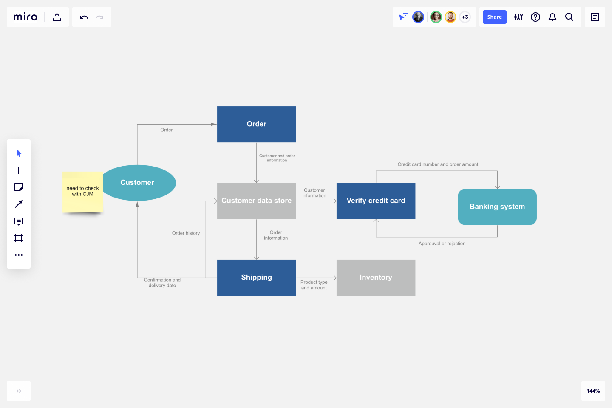

**Gantt Chart**

**Feasibility Study**

As the name implies, a feasibility analysis is used to determine the viability of an idea, such as ensuring a project is legally and [technically feasible](https://en.wikipedia.org/wiki/Feasibility_study#Technical_feasibility) as well as economically justifiable. It tells us whether a project is worth the investment—in some cases, a project may not be doable. There can be many reasons for this, including requiring too many resources, which not only prevents those resources from performing other tasks but also may cost more than an organization would earn back by taking on a project that isn’t profitable.

A well-designed study should offer a historical background of the business or project, such as a description of the product or service, accounting statements, details of operations and management, marketing research and policies, financial data, legal requirements, and tax obligations. Generally, such studies precede technical development and project implementation.

## **Types of Feasibility Study**

A feasibility analysis evaluates the project’s potential for success; therefore, perceived objectivity is an essential factor in the credibility of the study for potential investors and lending institutions. There are four types of feasibility study—separate areas that a feasibility study examines, described below.

1. **Economical Feasibility**

System is economical feasible and can be easily implement with minimum hardware and software resources as this is a cloud based application platform is provided by cloud provider only there is a need of Internet connection and a Browser application. It is very important for designer to first analyze the system economically and determines that project is economical feasible or not. Costs and benefits of the proposed computer system must always be considered together, because they are interrelated and often interdependent. Although the systems analyst is trying to propose a system that fulfills various information requirements, decisions to continue with the proposed system will be based on a cost-benefit analysis, not on information requirements. In many ways, benefits are measured by costs, as becomes apparent in the next section.

Systems analysts are required to predict certain key variables before the proposal is submitted to the client. To some degree, a systems analyst will rely on a what-if analysis, such as, “What if labor costs rise only 5 percent per year for the next three years, rather than 10 percent?” The systems analyst should realize, however, that he or she cannot rely on what-if analysis for everything if the proposal is to be credible, meaningful, and valuable.

The systems analyst has many forecasting models available. The main condition for choosing a model is the availability of historical data. If they are unavailable, the analyst must turn to one of the judgment methods: estimates from the sales force, surveys to estimate customer demand, Delphi studies (a consensus forecast developed independently by a group of experts through a series of iterations), creating scenarios, or drawing historical analogies.

If historical data are available, the next differentiation between classes of techniques involves whether the forecast is conditional or unconditional. Conditional implies that there is an association among variables in the model or that such a causal relationship exists. Common methods in this group include correlation, regression, leading indicators, econometrics, and input/output models.

Unconditional forecasting means the analyst isn’t required to find or identify any causal relationships. Consequently, systems analysts find that these methods are low-cost, easy-to-implement alternatives. Included in this group are graphical judgment, moving averages, and analysis of time-series data. Because these methods are simple, reliable, and cost effective, the remainder of the section focuses on them.

### Estimation of Trends

Trends can be estimated in a number of different ways. One way to estimate trends is to use a moving average. This method is useful because some seasonal, cyclical, or random patterns may be smoothed, leaving the trend pattern. The principle behind moving averages is to calculate the arithmetic mean of data from a fixed number of periods; a three-month moving average is simply the average of the last three months. For example, the average sales for January, February, and March is used to predict the sales for April. Then the average sales for February, March, and April are used to predict the sales for May, and so on.

When the results are graphed, it is easily noticeable that the widely fluctuating data are smoothed. The moving average method is useful for its smoothing ability, but at the same time it has many disadvantages. Moving averages are more strongly affected by extreme values than by using graphical judgment or estimating using other methods such as least squares. The analyst should learn forecasting well, as it often provides information valuable in justifying the entire project.

### Tangible Costs

The concepts of tangible and intangible costs present a conceptual parallel to the tangible and intangible benefits discussed already. Tangible costs are those that can be accurately projected by the systems analyst and the business’s accounting personnel.

Included in tangible costs are the cost of equipment such as computers and terminals, the cost of resources, the cost of systems analysts’ time, the cost of programmers’ time, and other employees  
salaries. These costs are usually well established or can be discovered quite easily, and are the costs that will require a cash outlay of the business.

### Intangible Costs

Intangible costs are difficult to estimate and may not be known. They include losing a competitive edge, losing the reputation for being first with an innovation or the leader in a field, declining company image due to increased customer dissatisfaction, and ineffective decision making due to untimely or inaccessible information. As you can imagine, it is next to impossible to project a dollar amount for intangible costs accurately. To aid decision makers who want to weigh the proposed system and all its implications, you must include intangible costs even though they are not quantifiable.

**1. Technical Feasibility**

It is the study of the function performance and constraints that may affect the ability to achieve an acceptable system. The project development requires designer to have technical knowledge of salesforce.com for both application development and database system. Technical feasibility is one of the most important criteria for selecting material for digitisation. The physical characteristics of source material and the project goals for capturing, presenting and storing the [digital surrogates](https://www.sciencedirect.com/topics/computer-science/digital-surrogate) dictate the technical requirements. Libraries must evaluate those requirements for each project and determine whether they can be met with the resources available. If the existing staff, hardware and software resources cannot meet the requirements, then the project will need funding to upgrade equipment or hire an outside conversion agency. If these resources are not available, or if the technology does not exist to meet the requirements, then it is not technically feasible to digitise that material.

Considerations for technical feasibility include:

* **Image capture:** Image capture requires equipment, such as a scanner or a digital camera. Different types of material require different equipment, and different equipment produces images of differing quality. When selecting materials for digitising, technical questions that need to be addressed include: does the original source material require high resolution to capture? Are there any oversized items in the collection? Are there any bound volumes in the collection? What critical features of the source material must be captured in the digital product? In what condition are the source materials? Will they be damaged by the [digitisation process](https://www.sciencedirect.com/topics/computer-science/digitisation-process" \o "Learn more about Digitisation Process from ScienceDirect's AI-generated Topic Pages)?
* **Presentation**: Presentation refers to how the [digitised materials](https://www.sciencedirect.com/topics/computer-science/digitized-material" \o "Learn more about Digitized Material from ScienceDirect's AI-generated Topic Pages) will be displayed online. Consider the following questions to determine the technical feasibility of presenting the digitised material:

Will the materials display well digitally?

How will users use the digital versions?

How will users navigate within and among digital collections?

Do the institutionally supported platforms and networked environment have the capability for accessing the images and delivering them with reasonable speed to the target audience?

Do the images need to be restricted to a specified community?

Do the images need special display features such as zooming, panning and page turning?

* **Description:** Some archival and special collections have been catalogued for public use and contain detailed finding aids with descriptions about each item and the collection as a whole. Other collections may not have been reviewed and documented in detail and do not have much information on individual items. Those collections will require more time, human resources and significant additional expense to research the materials, check the accuracy of the information obtained, and write appropriate descriptions to aid in discovery and use of the digital items. Typewritten documents, like the Drew Pearson columns described above, can have reasonably accurate OCR applied to them to replace, for some uses, the detailed descriptions required for discovery of hand-written or picture materials. The selection criteria should clearly state whether the items and collections that do not contain descriptions should be considered for digitisation.
* **Human resources**: When selecting materials for digitisation, the library should consider whether it has the staff and skill sets to support the digitisation, metadata entry, user interface design, programming and search engine configuration that is required for the project to implement the desired functionality. For large collaborative projects, dedicated staff are usually required from each partner. Digital collections also require long-term maintenance, which needs to be considered and planned for. If a project does not have the necessary staff and skills in-house, but funding is available, outsourcing may be a good choice.

**2. Behavioural Feasibility**

In the application domain our system works as an application. There are simple form to fill and service requires no ambiguous entries, all the behavioural entries are simple and GUI based. The system design is very user friendly, interactive. The application should be used by Administrator. People are inherently resistant to change, and computers have been known to facilitate change. An estimate should be made of how strong a reaction the user staff is likely to have toward the development of a computerized system. [t is common knowledge that computer installations have something to do with turnover, transfers, retraining, and changes in employee job status. Therefore, it is understandable that the introduction of a candidate system requires special effort to educate, sell, and train the staff on new ways of conducting business.  
  
In our safe deposit example, three employees are more than 50 years old and have been with the bank over 14 years, four years of which have been in safe deposit. The remaining two employees are in their early thirties. They joined safe deposit about two years before the study. Based on data gathered from extensive interviews, the younger employees want the programmable aspects of safe deposit (essentially billing) put on a computer. Two of the three older employees have voiced resistance to the idea. Their view is that billing is no problem. The main emphasis is customer service-personal contacts with customers. The decision in this case was to go ahead and pursue the project.

1. **Operational Feasibility**

Operational feasibility is the measure of how well a proposed system solves the problems, and takes advantage of the opportunities identified during scope definition and how it satisfies the requirements identified in the requirements analysis phase of system development.[[10]](https://en.wikipedia.org/wiki/Feasibility_study#cite_note-SAD-Global_Enterprise-10)

The operational feasibility assessment focuses on the degree to which the proposed development project fits in with the existing business environment and objectives with regard to development schedule, delivery date, [corporate culture](https://en.wikipedia.org/wiki/Corporate_culture) and existing business processes.

To ensure success, desired operational outcomes must be imparted during design and development. These include such design-dependent parameters as reliability, maintainability, supportability, usability, producibility, disposability, sustainability, affordability and others. These parameters are required to be considered at the early stages of design if desired operational behaviours are to be realised. A system design and development requires appropriate and timely application of engineering and management efforts to meet the previously mentioned parameters. A system may serve its intended purpose most effectively when its technical and operating characteristics are engineered into the design. Therefore, operational feasibility is a critical aspect of systems engineering that needs to be an integral part of the early design phases

An example of an operational feasibility study, or the fourth type, analyzes the inside operations on how a deemed process will work, be implemented, and how to deal with change resistance and acceptance.

Operational feasibility studies are generally utilized to answer the following questions:

* **Process** – How do the end-users feel about a new process that may be implemented?
* **In-House Strategies** – How will the work environment be affected? How much will it change?
* **Adapt & Review** – Once change resistance is overcome, explain how the new process will be implemented along with a review process to monitor the process change.

If an operational feasibility study must answer the six items above, how is it used in the real world? A good example might be if a company has determined that it needs to totally redesign the workspace environment.

After analyzing the technical, economic, and scheduling feasibility studies, next would come the operational analysis. In order to determine if the redesign of the workspace environment would work, an example of an operational feasibility study would follow this path based on six elements:

* **Process** – Input and analysis from everyone the new redesign will affect along with a data matrix on ideas and suggestions from the original plans.
* **Evaluation** – Determinations from the process suggestions; will the redesign benefit everyone? Who is left behind? Who feels threatened?
* **Implementation** – Identify resources both inside and out that will work on the redesign. How will the redesign construction interfere with current work?
* **Resistance** – What areas and individuals will be most resistant? Develop a [change resistance plan](https://www.brighthubpm.com/change-management/15306-change-management-methodology-for-beginners/).
* **Strategies** – How will the organization deal with the changed workspace environment? Do new processes or structures need to be reviewed or implemented in order for the redesign to be effective?
* **Adapt & Review** – How much time does the organization need to adapt to the new redesign? How will it be reviewed and monitored? What will happen if through a monitoring process, additional changes must be made?

The most important part of operational feasibility study is input—from everyone, especially when it affects how or what an organization does as far as processes. If the process were to build a new sports arena for a client, then a study determining how the arena will operate in a way that is conducive to its inhabitants, parking, human flow, accessibility and other elements is a good example of an operational feasibility study.

Create a [sample operational feasibility study](https://www.brighthubpm.com/project-planning/63692-project-feasibility-study-samples/) if you plan to change something inside the company that will affect how the organization runs or when a client asks you to explore a new product or process that will affect elements within their own organization.

**Test Case**

* **BLACK BOX TESTING** :-

The technique of testing without having any knowledge of the interior workings of the application is called black­box testing. The tester is oblivious to the system architecture and does not have access to the source code. Typically, while performing a black­box test, a tester will interact with the system's user interface by providing inputs and examining outputs without knowing how and where the inputs are worked upon.

* **WHITE BOX TESTING:-**

White­box testing is the detailed investigation of internal logic and structure of the code. White­box testing is also called glass testing or open­box testing. In order to perform white­box testing on an application, a tester needs to know the internal workings of the code.

* **GREY BOX TESTING**:-

Grey­box testing is a technique to test the application with having a limited knowledge of the internal workings of an application. In software testing, the phrase the more you know, the better carries a lot of weight while testing an application.

* **UNIT TESTING:-**

Unit Testing contains the testing of each unit of Recruitment Application. We have tested each interface by input values and check whether it is working properly working or not we also tested database connectivity. We have entered value in interface and check that the values are properly goes to corresponding tuples or not.

* **INTEGRATION TESTING:-**

Integration testing is defined as the testing of combined parts of an application to determine if they function correctly. Integration testing can be done in two ways: Bottom­up integration testing and Top­down integration testing.

* **SYSTEM TESTING**:-

System testing tests the system as a whole. Once all the components are integrated, the application as a whole is tested rigorously to see that it meets the specified Quality Standards. This type of testing is performed by a specialized testing team.

* **ACCEPTANCE TESTING:-**

This is arguably the most important type of testing, as it is conducted by the Quality Assurance Team who will gauge whether the application meets the intended specifications and satisfies the client’s requirement. The QA team will have a set of pre­written scenarios and test cases that will be used to test the application. In System Testing we have tested entire Recruitment Application. We have run all programs as a single system and inputs various test cases and analyse that all are going correctly or not. In system testing we have tested various test cases. According to which, Application showed the corresponding error message

**Conclusion**

The package was designed in such a way that future modifications can be done easily.

Automation of the entire system improves the efficiency.

It provides a friendly graphical user interface which proves to be better when compared to the existing system.

It gives appropriate access to the authorized users depending on their permissions.

A software project means a lot of experience. We learned a lot through this project. This project has sharpened our concept game engine, animation, and the software-hardware interface. We learned a lot about different documentation. Now I have much wider knowledge of the features Java offers and put into practice various object-oriented methods that learnt last semester.

**References**

**[1] .NET 4 for Enterprise Architects and Developers**

**[2] Model-Based Software Testing and Analysis with C#**

**[3] PROGRAMMING IN C#**

**[4] Data Structures and Algorithms Using Visual Basic.NET**

**[5] Object-Oriented Programming with Visual Basic.NET**

**[6] Process Engineering and Design Using Visual Basic**

**[7] Data Structure and Software Engineering**

**[8] Software Application Development**

**[9] Real-Time Software Design for Embedded Systems**

**[10] Embedded Software Development**

**[11] Component-Based Software Engineering**

**[12] Business Modeling and Software Design**